

**Maestro® Rechargeable System**

**Instructions for Use**

CAUTION: Federal Law restricts this device to sale by or on the order of a physician.

Copyright 2015 by EnteroMedics Inc., St. Paul, Minnesota

All rights reserved

EnteroMedics, VBLOC and Maestro are registered trademarks of EnteroMedics Inc.

The Maestro System is protected under U.S., European, Japanese and Australian Patents, and patent applications.

Subject to Pat. Nos.: AU2004209978; AU2009245845; AU2006280277; AU2006280278; AU2008226689; AU2008259917; AU2011265519; US 7,167,750; US 7,672,727; US 7,822,486; US 7,917,226; US 8,010,204; US 8,068,918; US 8,103,349; US 8,140,167; US 8,483,830; US 8,483,838; US 8,521,299; US 8,532,787; US 8,538,542; US 8,825,164; JP 5486588; EP 1601414; EP 1603634; EP 1922109; and EP1922111

For use in a method covered by Pat. Nos.: AU2009231601; US 7,489,969; US 7,729,771; US 7,613,515; US 7,844,338; US 8,046,085; US 8,538,533

Table of Contents

1. Indications for Use 4

2. Contraindications 5

3. Warnings 6

4. Precautions 8

5. Device Description 14

6. Symbols & Definitions 17

7. Storage, Sterilization & Handling 19

7.1 Re-Sterilization or Re-Use of Maestro Rechargeable System Components 20

7.2 Environment 20

8. Potential Adverse Events 21

9. CLINICAL STUDY 22

9.1 Primary Efficacy Objectives 22

9.2 Primary Safety Objective 22

9.3 Subject Disposition 22

9.4 Primary Safety Endpoint 24

9.4.1 All Serious Adverse Events 25

9.4.2 Overview of All Adverse Events Related to Device, Therapy or Procedure 26

9.4.3 Adverse Events Leading to Study Withdrawal 26

9.4.4 Surgical Removals of the Device 27

9.4.5 Surgical Revisions 27

9.5 Effectiveness 27

9.5.1 Change in %EWL and %Total Body Weight Loss (%TBL) 28

9.5.2 Responder Analyses 29

9.5.3 Improvements in Obesity Risk Factors 29

9.6 Updated Results through 18 Months 30

10. Individualization of Treatment 32

10.1 Patient Selection 32

10.2 Use in Specific Populations 32

10.3 Patient Counseling 32

11. Operating Instructions 33

11.1 Using the Mobile Charger 37

11.2 Maestro Rechargeable System Preparation Prior to Implantation 39

12. Implant Procedure Summary 43

13. Lead Status (Impedance) Test in Surgery 46

14. Device Activation and Treatment Initiation during Surgery 49

14.1 Device Activation and Therapy Initiation 49

14.2 Post Implant Healing Period 51

15. Modifying Therapy Parameters during Follow-Up Visits 52

15.1 First Follow-Up Visit 52

15.2 Successive Follow-Up Visits 53

15.3 Maestro Rechargeable System Reports 55

16. Maintaining the Maestro Rechargeable System 56

16.1 Maintaining the Neuroregulator 56

16.2 Maintaining the Mobile Charger and Transmit Coil 56

17. Patient Operating Instructions 57

17.1 Positioning the Transmit Coil over the Neuroregulator 57

17.2 Checking Neuroregulator and Mobile Charger Battery Charge Levels 58

17.3 Charging the Battery in the Neuroregulator 59

17.4 Restoring the Mobile Charger’s Default Settings 60

17.5 System Alerts 60

18. Deactivating the Neuroregulator 61

19. Implant Removal and Disposal Instructions 62

19.1 Device Removal Training 62

19.2 Removal of All Implantable Device Components 62

19.3 Replacement of Neuroregulator 63

19.4 Device Disposal 63

20. Specifications 64

20.1 Component and Therapy Specifications 64

20.2 Electromagnetic Compatibility Tables 67

21. Maestro Rechargeable System Limited Warranty 71

22. Contact Information 73

# Indications for Use

The Maestro Rechargeable System is indicated for use in weight reduction in patients aged 18 years through adulthood who have a Body Mass Index (BMI) of 40 to 45 kg/m2, or a BMI of 35 to 39.9 kg/m2 with one or more obesity related co-morbid conditions, and have failed at least one supervised weight management program within the past five years.

# Contraindications

**Y** Patients with cirrhosis of the liver, portal hypertension, esophageal varices or an uncorrectable, clinically significant hiatal hernia.

**Y** Patients for whom magnetic resonance imaging (MRI) is planned.

**Y** Patients at high risk for surgical complications

**Y** Patients who have a permanently implanted, electrical-powered medical device or gastrointestinal device or prosthesis (e.g. pacemakers, implanted defibrillators, neurostimulators)

**Y** Patients for whom shortwave, microwave, or therapeutic ultrasound diathermy is planned

Diathermy is any treatment that uses high-frequency electromagnetic radiation, electric currents, or ultrasonic waves to produce heat in body tissues. Patients absolutely CANNOT be treated with any type of shortwave, microwave, or therapeutic ultrasound diathermy device whether or not it is used to produce heat. These treatments should not be applied anywhere on the body.

# Warnings

**Y** Certain medical therapies or procedures may cause injury to the patient, permanent damage to the implant or may turn therapy off; particularly if used in close proximity to the device. Therapies or procedures which may affect the tissue/electrode interface or the neuroregulator may result in dislodgement, loss of therapy or nerve damage. Therapies and procedures that induce current through the lead and neuroregulator could cause nerve damage, burns, heating or pain. These include:

* Shock wave lithotripsy;
* Oncologic radiation or any cobalt 60 or gamma radiation;
* Mono Polar electrosurgical instruments;
* Positron emission tomography (PET) scans; or
* Radiofrequency ablation
* Patients absolutely CANNOT be treated with any type of shortwave, microwave, or therapeutic ultrasound diathermy device whether or not it is used to produce heat. These treatments should not be applied anywhere on the body. Diathermy is any treatment that uses high-frequency electromagnetic radiation, electric currents, or ultrasonic waves to produce heat in body tissues.

**Y** Patients with Twiddler’s Syndrome may move, damage or disconnect the lead from the neuroregulator. This may interfere with therapy delivery, recharging or may result in damage to the vagus nerves.

**Y**  Failure to maintain adequate charge of the neuroregulator may result in additional surgery to replace the device. The neuroregulator must be fully charged at least once every two months. If the neuroregulator is not regularly charged, the battery may no longer be chargeable and therapy may no longer be able to be delivered.

**Y**  If the decision is made to stop therapy, the neuroregulator must be fully charged prior to deactivation. Verify that the neuroregulator is fully charged before it is turned off. A deactivated neuroregulator may be turned on with clinician programmer.

**Y** Lead impedance testing should only be performed using equipment approved by EnteroMedics since leakage current could injure the patient.

**Y** Continuedtherapy with a fracturedlead may result in conductor dissolution resulting in pain, inflammation or nerve damage.

**Y** The Maestro System is MR Unsafe. Patients should register their implant information with the MedicAlert Foundation (www.medicalert.org) or equivalent organization.

**Y** MR is categorized as unsafe for patients in which the Maestro System was explanted and not all components were removed.

# Precautions

**Y** The safety and effectiveness of this device has not been determined for patients under the age of 18 years

**Y** The Maestro Rechargeable System should only be implanted by surgeons specifically trained to perform the Maestro Rechargeable System implant procedure.

**Y** The Maestro Rechargeable System may interact with implantable devices such as cardiac pacemakers and defibrillators, implanted spinal cord and peripheral nerve stimulators, other neurostimulators, and body worn medical devices, such as insulin pumps. Possible effects of the system interaction with implanted cardiac devices include that defibrillation therapy from an implanted defibrillator may damage the RNR. Electrical pulses from the RNR may interact with the sensing operation of an implantable or body worn device and may result in an inappropriate response of the device.

**Y**  If radiation therapy is required, the area over the neuroregulator should be shielded with lead to protect the implant from damage.

**Y** Maestro Rechargeable System components produce small electrical currents that may ignite flammable liquids and gasses. Do not operate the system in flammable environments, including flammable anesthetics.

**Y** Use only Maestro Rechargeable System components listed in Table 1 of this document. Only leads listed in this table should be used with the Maestro Rechargeable System neuroregulator.

**Y** Handle leads with care. Avoid stretching, kinking, or handling with surgical instruments that may cause permanent damage to lead components including the lead body, electrode, conductor, or connector. Do not attempt to bend or modify the electrode during implant.

**Y** Maestro Rechargeable System programming should be performed only by trained personnel under physician supervision.

**Y** To ensure reliable operation, the AC recharger should be not connected to a portable multiple outlet socket or extension cord.

**Y** The mobile charger case may become warm during recharging of the neuroregulator. To avoid damage to the equipment place the mobile charger in a position that allows air circulation, do not lie in bed, sleep, sit or lie on the mobile charger, place the mobile charger in clothing or place the mobile charger within a carrying case.

**Y** To ensure reliable recharging of the neuroregulator, there must be no metal or magnetic objects within six inches of the implanted neuroregulator and transmit coil.

**Y** The mobile charger and transmit coil have limited protection from fluids and may be damaged when immersed in liquids or used in wet environments. Patients should not bathe, shower, or swim with the mobile charger and transmit coil.

**Y** Do not use any component of the Maestro System if it appears to be damaged.

**Y** A strong magnet, such as those found in speakers, Cathode Ray Tubes (including television tubes), electric motors, refrigerator and freezer doors, power tools, as well as magnets used therapeutically or worn on the body in close proximity to the neuroregulator may inactivate the device. Patients should be cautioned to keep such devices at least six (6) inches away from the neuroregulator. If your device becomes inactivated because of exposure to a strong magnetic field, then you must schedule a visit with a clinician to reactivate the neuroregulator.

**Y**  The mobile charger should not be turned on aboard aircraft.

**Y** Maestro Rechargeable System components are to be returned to EnteroMedics for safe and proper disposal. Under no circumstances should Maestro Rechargeable System components be disposed of by incineration, including cremation.

**Y** The capacity of the rechargeable battery in the implanted neuroregulator will diminish over time with use. This may require longer or more frequent charging as the implanted neuroregulator nears the end of its useful life.

**Y** Electronic components of the Maestro Rechargeable System may be damaged by therapeutic ionizing radiation; damage may not be immediately detectable.

**Y** The effects on device safety, operation or performance when used within a hyperbaric chamber are unknown. Patients implanted with the Maestro Rechargeable System should seek medical guidance prior to entering a hyperbaric chamber.

**Y** Radio Frequency Identification (RFID) systems may interfere with the communication system in your Maestro System and may result in longer charging times and/or a not fully charged RNR battery. The clinician should be aware that RFID systems in close proximity to the Maestro System in the clinic may result in difficulty with interrogation and programming of the RNR. RFID sources may be present in health care facilities, retail stores, libraries, airports and business environments.

**Y** Strong magnetic fields and sources of strong electromagnetic interference emitted from RF emitters like those emitted by electronic article surveillance (EAS) systems, metal detectors, other security systems, lithotripsy, computer monitors, motorized wheel chairs, x-ray equipment and other monitoring equipment may be present in the home, work, medical, or public environments. The effects of these RF emitters are unknown but may be strong enough to interfere with the function of the Maestro System and may produce the following effects:

* Serious injury; it is possible for these sources to generate enough energy in the Maestro leads to damage the vagal nerve and surrounding tissue.
* Damage to the Maestro System; resulting in permanent loss of therapy.
* Operational changes to the RNR; turning therapy off.

Strong magnetic fields and RF emitters, including RFID systems, may not always be visible and could result in inadvertent exposure without your awareness. You should move away from these sources to avoid close proximity (indicated in the table of “Recommended separation distances between portable and mobile RF communications equipment and the Maestro Rechargeable System”) and never recharge your RNR in the vicinity of these sources. We recommend that you turn the RNR off, using your MC, before you enter an area with known strong magnetic fields or EMI. If your device becomes inactivated because of exposure to a strong magnetic field, then you must schedule a visit with a clinician to reactivate the RNR.

The Maestro Rechargeable System may activate EAS systems, metal detectors or other security systems. Patients should be advised not to recharge the Maestro Rechargeable System neuroregulator and to turn the mobile charger off in the presence of these systems.

**Y** Infections at the implant site have been observed, and severe infections could require surgery and device explantation. Administration of appropriate broad-spectrum antibiotics, as per standard of care, should be considered pre-, peri-, and post-operative to the implant procedure.

**Y** Allergic reaction to the materials of the Maestro System components is possible.

**Y** The leads can become entangled or fractured, or the insulation can erode. Avoid using excess lead length in the neuroregulator pocket.

**Y** The safety and effectiveness of defibrillation devices used on patients with the Maestro Rechargeable system has not been established. If use of a defibrillator is necessary, it is possible that defibrillation current may be conducted through the leads, possibly reducing the effectiveness of the defibrillation and damaging the nerves.

**Y** The safety and effectiveness of the Maestro Rechargeable System have not been established for use during pregnancy. As soon as pregnancy has been confirmed, the VBLOC therapy must be turned off and the neuroregulator must be fully charged and deactivated by the clinician. Because the leads are implanted in the abdomen, the position of the leads relative to the fetus should be monitored on a regular basis. The Maestro Rechargeable System has not been tested with fetal monitoring systems and may interfere with its operation.

**Y** Normal operating range of the neuroregulator is between 16°C (60°F) and 45°C (113°F). Exposure to conditions which cause the temperature of the neuroregulator to be out of this range should be avoided. This includes, but is not limited to exposure to electric blankets, heating pads, and saunas which exceed 45°C (113°F). When exposed to temperatures outside this range while implanted, the neuroregulator will turn off and the red status icon will be illuminated on the mobile charger when communicating with the neuroregulator. The patient must schedule a visit with a clinician to reactivate the neuroregulator.

**Y** Do not modify any of the components of the Maestro Rechargeable System. Effects of component modification on the device safety, performance or operation are unknown. Changes or modifications not expressly approved by the manufacturer could void the user's authority to operate the equipment.

**Y** Some functions of the Maestro Rechargeable System such as neuroregulator battery charging, transmit coil positioning and device interrogation rely on a radio frequency telemetry link between the neuroregulator and mobile charger. Interference from radio frequency transmitters in very close proximity to the neuroregulator and mobile charger may affect these functions. Issues may be resolved by moving to a different location where less interference is present.

**Y** Interference to the radio frequency telemetry link between the neuroregulator and mobile charger may be experienced in countries outside the United States, where frequency allocations and radio transmission parameters may differ from those in the USA.

**Y** The radio frequency telemetry link between the neuroregulator and mobile charger may stop functioning when two or more Maestro Rechargeable Systems are operating within 10 cm of each other. The telemetry link will be re-established and normal operation will resume when this distance is increased to greater than 10 cm.

**Y** Unintended access to the neuroregulator disc is prevented by the short range of radio telemetry link and the way the neuroregulator disc and mobile charger communicate.

**Y** Patients with impaired vision may not be able to successfully operate the Maestro System.

**Y** This Maestro Rechargeable System equipment has been tested and found to comply with the limits for a Class B digital device, pursuant to part 15 of the FCC Rules. These limits are designed to provide reasonable protection against harmful interference when the equipment is operated in a residential setting. However, there is no guarantee that interference will not occur. This equipment generates, uses and can radiate radio frequency energy and, if not used in accordance with the instructions, may cause harmful interference to radio communications. If operation of this equipment does cause harmful interference to radio or television reception, which can be determined by turning the equipment off and on, the user is encouraged to try to correct the interference by one or more of the following measures:

* Increase the separation distance between the mobile charger and transmit coil or the mobile charger and AC recharger from the affected device.
* Connect the AC recharger into a different outlet on a circuit different from that to which the affected device is connected.
* Contact EnteroMedics for additional suggestions.

**Y** This transmitter must not be co-located or operating in conjunction with any other antenna or transmitter, except in accordance with FCC multi-transmitter product procedures.

# Device Description

The Maestro Rechargeable System is comprised of multiple implantable and external components. The primary components are:

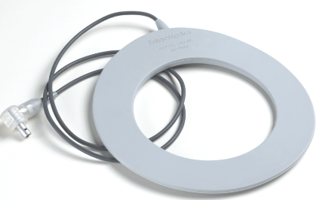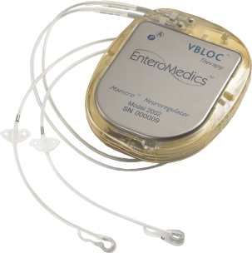

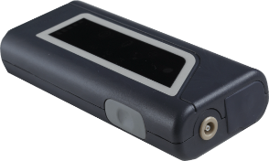

**Rechargeable Neuroregulator and Leads**

**Mobile Charger**

**Transmit Coil**

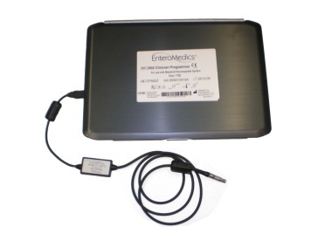

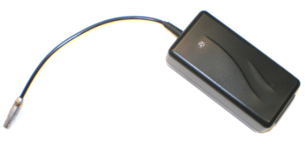

**Clinician Programmer and Programmer Cable**

**AC Recharger**

Implantable components of the system include the neuroregulator and two leads. External components of the system include a mobile charger, transmit coil, AC recharger, and a clinician programmer.

Energy is transferred from the implanted neuroregulator to leads connected to the patient’s anterior and posterior vagus nerves providing blocking or regulation of nerve function. The transmit coil, when connected to the mobile charger and positioned over the neuroregulator, is used to determine the status of the implanted device and recharge the battery as required. The clinician programmer consists of a laptop computer with specialized software which may be used to transmit information to, and upload data from the neuroregulator. The data is available to the clinician to determine any changes in treatment regimens and to monitor the performance of the Maestro Rechargeable System and patient compliance with device charging.

The system components are listed in Table 5‑1.

**Table 5‑1: Maestro Rechargeable System Components**

| **Component** | **Model Number** | **Sterility** | **Shelf Life** | **Single use / Multi Use** |
| --- | --- | --- | --- | --- |
| **Implantable Components** |  |  |  |  |
| Neuroregulator | 2002 | Sterile | 18 months from the date of sterile packaging | Single Use |
| Posterior Lead | 2200P – 47E | Sterile | 36 months from the date of sterile packaging | Single Use |
| Anterior Lead | 2200A – 47E | Sterile | 36 months from the date of sterile packaging | Single Use |
|  |  |  |  |  |
| **External Components** |  |  |  |  |
| Mobile Charger | 2402 | Not Sterile | Indefinite, no shelf life specified | **Multiple Use  (1 patient, or 1 clinician office with multiple patients) |
| Transmit Coil | 2403-60 | Not Sterile | Indefinite, no shelf life specified | **Multiple Use  (1 patient) |
| AC Recharger | 1620 | Not Sterile | Indefinite, no shelf life specified | ** Multiple Use (1 patient, or 1 clinician office with multiple patients) |
| *Clinician Transmit Coil | 2403-300 | Not Sterile | Indefinite, no shelf life specified | ** Multiple Use (1 clinician office, multiple patients) |
| *Clinician Programmer | 2502 | Not Sterile | Indefinite, no shelf life specified | ** Multiple Use (1 clinician office, multiple patients) |
| *Programmer Cable (connects Mobile Charger to Clinician Programmer) | 1600 | Not Sterile | Indefinite, no shelf life specified | ** Multiple Use (1 clinician office, multiple patients) |
|  |  |  |  |  |
| **Accessories** |  |  |  |  |
| Belt for use with 2403-60 Transmit Coil | 1660 | Not Sterile | Indefinite, no shelf life specified | ** Multiple Use (1 patient) |
| Torque Wrench | 1680 | Sterile | 18 months from the date of sterile packaging | Single Use |
|  |  |  |  |  |
| **Instructions for Use** |  |  |  |  |
| Maestro Rechargeable System Instructions for Use | P01392-001 (Available on Model 2502 Clinician Programmer) | NA | NA | NA |
| Patient Instructions | P01395-001 (Available on Model 2502 Clinician Programmer) | NA | NA | NA |
| Model 2502 Clinician Programmer Manual | P01394-001 (Available on Model 2502 Clinician Programmer) | NA | NA | NA |
| Surgical Implant Procedure | P01393-001 (Available on Model 2502 Clinician Programmer) | NA | NA | NA |
| Easy Charge Guide | P01396-001 | NA | NA | NA |

* Note: These components are not intended for use by the patient.

** Note: Reprocessing Not Required

# Symbols & Definitions

D Do Not Reuse

I Device Sterilized by Ethylene Oxide

H Use By (Expiration Date)

M Manufacturer’s Identification

N Manufactured On (date of manufacture)

Y Caution, consult accompanying documents

i Consult the manual before use

h Catalog or reference number

g Batch Code

f Serial Number

**P** Authorized Representative

 Type BF applied part

 Defibrillation-proof Type BF applied part

 Device incorporates an RF transmitter

**image001**     Shipping and storage temperature range

 Shipping and storage pressure range

 Shipping and storage humidity range

IP22 Protected against access to hazardous parts with a finger, protected against solid foreign objects of 12.5 mm in diameter and greater, and protected against vertically falling water drops when enclosure tilted up to 15°

 Magnetic Resonance Imaging Unsafe

 Length of Leads

 Electrode Spacing of Leads

 Trocar Size for Lead Placement

# Storage, Sterilization & Handling

**Y** Store the clinician programmer and mobile charger at room temperature. Storage temperatures must be within -10°C (14° F) or 55° C (131° F).

**Y** Normal operating range for the mobile charger is from 15°C (59° F) to 40°C (108° F) and 10% to 90% relative humidity.

**Y** Normal operating range of the neuroregulator is between 16°C (60°F) and 45°C (113°F). If the neuroregulator is exposed to temperatures outside this range while implanted, the device will turn off and the red status icon will be illuminated on the mobile charger. If the red status icon is illuminated, the patient must schedule a visit with a clinician during normal business hours.

**Y** To avoid the risk of infections or adverse reactions by the patient’s immune system, the Maestro Rechargeable components intended for implant and the Torque Wrench are supplied in sterile packages. Inspect the sterile package prior to use. If the sterile package is damaged or the sterilization date has expired, do not implant the device or components and contact EnteroMedics.

**Y** Do not implant a lead or neuroregulator that has been dropped or damaged after removal from its sterile packaging. After medical adhesive has been applied to the neuroregulator, leads should not be reinserted. Use a new neuroregulator instead.

**Y** The lead insulation should not be damaged. Grasp only the suture tongue and/or the suture wing of the lead when using surgical tools. Do not tie sutures directly around the lead. Instead use the suture fixation features provided on the lead.

**Y** The clinician programmer and programmer cable are not intended to be sterilized or disinfected. The clinician programmer and programmer cable may be periodically cleaned by wiping with a damp cloth.

**Y** The mobile charger and AC Recharger are not intended to be sterilized or disinfected. The mobile charger and AC Recharger may be periodically cleaned by wiping with damp soapy cloth.

**Y** The Clinician Coil and Patient Transmit Coil are not intended to be sterilized or disinfected. The Clinician Coil and Patient Transmit Coil may be periodically cleaned by wiping with a damp soapy cloth.

**Y** Patient Transmit Coil Belt may be periodically cleaned by washing by hand or with a machine using a cold, gentle cycle and air dry.

.

**Y** Do not ultrasonically clean the leads or neuroregulator.

## Re-Sterilization or Re-Use of Maestro Rechargeable System Components

**Y** Implanted components cannot be reused and are not designed to be re-sterilized. Contact EnteroMedics for instructions regarding the return of any Maestro Rechargeable System components. Before returning any devices that have been exposed to patient bodily fluids, disinfect the device using a sterilant, such as Cidex® or equivalent. Place in a sealed container with proper identification including information regarding use of the device.

**Y** Re-use of a device carries the same risk as failure to sterilize since the complexity of an active device design can provide sites of attachment for environmental bacteria and/or small particulates. Additionally, there is the theoretical potential of reactions by the recipient's immune system to proteins introduced as a consequence of re-use.

**Y** The clinician transmit coil is not designed to be sterilized or disinfected.

## Environment

**Y** The mobile charger and transmit coil are not designed to be waterproof. Do not use or store the equipment in a wet or moist environment. The mobile charger is rated as IP22 drip proof.

# Potential Adverse Events

Potential adverse effects (e.g., complications) associated with the implantation procedure and/or use of the device are listed below. These adverse effects may or may not have been observed in clinical studies and clinical use of the Maestro Rechargeable System.

|  |  |
| --- | --- |
| **Potential Adverse Events** | |
| **Intra-operative** | **Post-operative** |
| Death  Respiratory complications  Cardiovascular complications  Bleeding  Esophageal perforation  Injury to abdominal organs (gastric perforation, ileus, etc.)  DVT/pulmonary embolus  Electrode misplacement  Electrode malfunction  Vagal nerve injury | Esophageal erosion  Organ entrapment or strangulation  Small bowel obstruction  Vagal nerve injury  Syncope  Chest pain  Wound dehiscence  Infection  Inflammation  Bloating  Cramps  Edema  Lead malfunction  Neuroregulator malfunction  Neuroregulator migration or erosion  Electric shock  Skin reaction  Delayed gastric emptying  Gastroparesis  Dumping syndrome  Heartburn  Diarrhea  Emesis  Constipation  Eructation  Nausea  Dysphagia  Energy decrease  Alopecia  Headache  Paresthesia  Pain at the neuroregulator site  Pain  Abdominal pain  Cough  Appetite changes  Flatulence  Dyspnea  Lightheadedness/Dizziness  Gallbladder disease  Steatorrhea  Vitamin deficiency  Psychosocial malfunction |

# CLINICAL STUDY

The ReCharge Study was a randomized, double-blind, sham-controlled trial to evaluate the safety and effectiveness of the Maestro Rechargeable System in treating obesity. Eligible subjects were randomized in a 2:1 allocation to undergo implantation with either an active treatment device to receive VBLOC therapy or a sham device. Subjects and Study Coordinators were blinded until 12-month follow-up visits were completed for all subjects, after which sham control subjects who chose to continue in the trial had the option to have a complete Maestro Rechargeable System implanted and receive therapy.

Type 2 diabetics were limited to 10% of randomized subjects (with no more than 3 subjects per center) and once the enrollment limit was reached, the centers were notified and type 2 diabetic enrollments were stopped.

The study was powered to assess a 20 percentage point difference in percentage Excess Weight Loss (%EWL) between the VBLOC and sham control groups allocated in a 2:1 ratio under a “super-superiority” design. With a 10% superiority margin and an assumed maximum 15% rate of attrition, it was determined that a minimum of 232 subjects would be required to power the primary efficacy objective at the 85% level.

The intent-to-treat (ITT) population was the primary analysis population for this trial. If a subject did not have primary endpoint data available at 12 months, the “last observation carried forward” (LOCF) imputation method was applied to the missing 12-month data points.

## Primary Efficacy Objectives

The first co-primary efficacy objective was to demonstrate a mean difference of at least 10% EWL between the VBLOC treatment and sham control arms (super-superiority), as measured by the body mass index (BMI) method, at 12 months post-randomization.

A second co-primary efficacy objective was to demonstrate a responder rate in the VBLOC treatment arm that achieved the following at 12 months:

* + At least 55% of treatment subjects achieved at least 20% EWL (BMI method)
* At least 45% of treatment subjects achieved at least 25% EWL (BMI method)

## Primary Safety Objective

The primary safety objective was to demonstrate that the rate of serious adverse events (SAEs) related to the implant/revision procedure, device, or therapy at 12 months was less than 15% in the VBLOC group.

## Subject Disposition

A total of 239 subjects were randomized in the ReCharge trial. One hundred sixty-two (162) subjects were randomized to receive a Maestro Rechargeable System (active device) and seventy seven (77) subjects were randomized to receive the sham control device. Two hundred and thirty-three subjects (233) were implanted (157 in the active VBLOC arm and 76 in the sham control arm). There were 15 subjects in the type 2 diabetes mellitus cohort (9 VBLOC group, 6 sham control group). Four subjects withdrew due to adverse events; two (1 VBLOC, 1 sham control) with pain at the neuroregulator site, one sham control subject due to breast cancer and one sham control subject due to anxiety. There were no withdrawals due to device malfunction. Seven additional VBLOC subjects withdrew before 12 months. Five were prior to implant due to the following reasons: one for discovery of cirrhotic liver at implant; three intra-operative exclusions of Nissen fundoplication, greater than 5 cm hiatal hernia, and extensive intra-operative dissection; and one at implant due to food discovered in the stomach after overnight fasting. Two remaining withdrawals were due to loss to follow-up after implant. Five additional sham subjects withdrew in the first year due to subject decision.

Six subjects were not implanted after they were randomized. These subjects are included in the ITT analysis.

At the 12-month visit, 89.1% of randomized subjects were available for follow-up. The average subject was approximately 47 years of age and Caucasian (92.9%). Nearly 85% of the subject population was female. Demographics and important baseline characteristics are presented in the following table. No significant differences between VBLOC and sham control subjects were observed at baseline on important demographic characteristics.

Table 9‑1: Baseline Demographic for VBLOC and Sham Control groups

| **Characteristic** | **VBLOC N=162** | **Sham Control N=77** | **P-value** |
| --- | --- | --- | --- |
| Gender |  |  |  |
| Female | 141 (87.0%) | 62 (80.5%) | 0.245 |
| Male | 21 (13.0%) | 15 (19.5%) |  |
| Age (years) at screening | 47.1 ± 10.3 | 46.6 ± 9.4 | 0.693* |
| Race |  |  |  |
| Caucasian | 149 (92.0%) | 73 (94.8%) | 0.592 |
| African American | 8 (4.9%) | 3 (3.9%) | 1.000 |
| Native American | 2 (1.2%) | 1 (1.3%) | 1.000 |
| Asian | 1 (0.6%) | 1 (1.3%) | 0.541 |
| Hawaiian/Pacific Islander | 1 (0.6%) | 0 (0.0%) | 1.000 |
| Height (m) at screening | 1.7 ± 0.1 | 1.7 ± 0.1 | 0.112* |
| BMI at implant (kg/m2) | 40.9 ± 2.8 | 40.9 ± 3.1 | 0.969* |
| Weight at implant (kg) | 112.6 ± 13.4 | 115.5 ± 14.3 | 0.117 |
| Excess weight (kg) at implant | 43.7 ± 8.7 | 44.9 ± 9.5 | 0.371 |
| Waist circumference (cm) at screening | 121.1 ± 11.8 | 123.0 ± 11.3 | 0.236 |
| Type 2 diabetes mellitus | 9 (5.6%) | 6 (7.8%) | 0.571 |
| Hypertension | 63 (38.9%) | 32 (41.6%) | 0.920 |
| Dyslipidemia | 91 (56.2%) | 46 (59.7%) | 0.884 |
| Obstructive sleep apnea | 33 (20.4%) | 23 (29.9%) | 0.267 |

Note: Data are presented as mean ± SD for continuous variables. Data are presented as n (%) for categorical variables. P-values for continuous variables were calculated using a Student's t-test (no asterisk) or a Wilcoxon rank sum test (*) if the variable was not normally distributed based on the Shapiro-Wilk normality test. Categorical variables were compared using Fisher's exact test.

## Primary Safety Endpoint

The primary safety SAE rate (Table 9‑2), defined as the proportion of subjects in the VBLOC group who experienced an implant/revision procedure, device or therapy-related SAE through 12 months post-implant, was 3.7% (n=6; 95% CI: 1.4% to 7.9%) in the ITT population. This rate was significantly lower than 15% (p<0.0001), so the primary safety endpoint was met. The type, origin, and relatedness of these SAEs are shown in Table 9‑3. All SAEs were adjudicated by the Clinical Events Committee (CEC).

Table 9‑2: Primary Safety Endpoint

| **VBLOC Group SAE Rate (95% CI) [n/N]** | **P-value (SAE Rate < 15%)** |
| --- | --- |
| 3.7% (1.4, 7.9) [6/162] | <.0001 |

Table 9‑3: Listing of Events for Primary Safety Endpoint

| **Subject ID** | **SAE Type** | **SAE Origin (Relatedness)** |
| --- | --- | --- |
| 301-303-RC | Neuroregulator malfunction | Device (Definite) |
| 301-325-RC | Pain, neuroregulator site | Device (Definite) |
| 311-309-RC | Atelectasis | Implant/revision procedure (Definite) |
| 311-319-RC | Neuroregulator malfunction | Device (Definite) |
| 313-323-RC | Gallbladder disease | Therapy algorithm (Possible) |
| 317-309-RC | Emesis (Vomiting) | Implant/revision procedure (Definite) |

Considering all SAEs in the primary safety endpoint as well as those related to the general surgical procedure (e.g., nausea), the rate was 8.6% (Table 9‑4), which was also significantly lower than 15%. These additional SAEs related to general surgical procedure included 6 cases of post-operative nausea, cirrhosis (subject not implanted), generalized ileus, and intra-operative oozing.

Table 9‑4: Rate of SAEs in Primary Safety Endpoint and SAEs Related to General Surgical Procedure

| **VBLOC Group SAE Rate (95% CI) [n/N]** | **P-value (SAE Rate < 15%)** |
| --- | --- |
| 8.6% (4.8, 14.1) [14/162] | 0.01 |

### All Serious Adverse Events

At 12 months, there were 27 SAEs among 22 VBLOC subjects (13.6%) and 4 SAEs among 4 sham control subjects (5.2%). All SAEs are listed by CEC-determined relatedness (Table 9‑5).

Table 9‑5: Serious Adverse Events by CEC Category

| **Serious Adverse Event** | **VBLOC**  **N=162** | | **Sham Control**  **N=77** | |
| --- | --- | --- | --- | --- |
| **N (%) subjects** | **N events** | **N (%) subjects** | **N events** |
| **SAEs related to device, implant/revision, or therapy** | | | | |
| Neuroregulator malfunction | 2 (1.2) | 2 | 0 (0.0) | 0 |
| Atelectasis | 1 (0.6) | 1 | 0 (0.0) | 0 |
| Gallbladder disease | 1 (0.6) | 1 | 0 (0.0) | 0 |
| Emesis/vomiting | 1 (0.6) | 1 | 0 (0.0) | 0 |
| Pain, neuroregulator site | 1 (0.6) | 1 | 0 (0.0) | 0 |
| **SAEs related to general surgical procedure** | | | | |
| Nausea | 6 (3.7) | 6 | 0 (0.0) | 0 |
| Cirrhosis* | 1 (0.6) | 1 | 0 (0.0) | 0 |
| Generalized ileus | 1 (0.6) | 1 | 0 (0.0) | 0 |
| Intra-operative oozing | 1 (0.6) | 1 | 0 (0.0) | 0 |
| **SAEs related to pre-existing condition or not related** | | | | |
| Allergic reaction | 1 (0.6) | 1 | 0 (0.0) | 0 |
| Chest pain | 1 (0.6) | 1 | 0 (0.0) | 0 |
| Colitis | 1 (0.6) | 1 | 0 (0.0) | 0 |
| Gallbladder disease | 1 (0.6) | 1 | 0 (0.0) | 0 |
| Gastritis | 0 (0.0) | 0 | 1 (1.3) | 1 |
| Infection, other | 1 (0.6) | 1 | 1 (1.3) | 1 |
| Osteoarthritis | 1 (0.6) | 1 | 0 (0.0) | 0 |
| Pain, abdominal | 1 (0.6) | 1 | 0 (0.0) | 0 |
| Pain, other | 2 (1.2) | 2 | 0 (0.0) | 0 |
| Palpitations | 1 (0.6) | 1 | 0 (0.0) | 0 |
| Pericarditis | 1 (0.6) | 1 | 0 (0.0) | 0 |
| Breast cancer | 0 (0.0) | 0 | 1 (1.3) | 1 |
| Worsening back pain | 0 (0.0) | 0 | 1 (1.3) | 1 |

* subject not implanted

### Overview of All Adverse Events Related to Device, Therapy or Procedure

The most common non-serious related AEs through 12 months are shown in Table 9‑6. The most common AE in both groups was pain at the neuroregulator site, although there was no statistical difference between groups. The rates of other pain and heartburn were statistically higher in the VBLOC group. This is not unexpected considering the differences in surgical procedure and therapy between the treatment groups.

Table 9‑6: Most Common Non-Serious Adverse Events Related to Device, Implant/Revision Procedure, or Therapy through 12 Months among Implanted Patients

| **AE Type** | **VBLOC N=157** | | **Sham Control N=76** | | **Difference [95% CI]** |
| --- | --- | --- | --- | --- | --- |
| **N patients (%)** | **N events** | **N patients (%)** | **N events** |
| Pain, neuroregulator site | 60 (38.2%) | 72 | 32 (42.1%) | 35 | -3.9% [-17.5, 9.8] |
| Other | 34 (21.7%) | 43 | 7 (9.2%) | 10 | 12.4% [-1.4, 25.9] |
| Heartburn/dyspepsia | 38 (24.2%) | 42 | 3 (3.9%) | 3 | 20.3% [6.5, 33.5] |
| Pain, other | 38 (24.2%) | 43 | 0 (0.0%) | 0 | 24.2% [10.5, 37.3] |
| Pain, abdominal | 20 (12.7%) | 26 | 2 (2.6%) | 2 | 10.1% [-3.7, 23.7] |
| Nausea | 7 (4.5%) | 8 | 1 (1.3%) | 1 | 3.1% [-10.5, 16.8] |
| Dysphagia | 13 (8.3%) | 13 | 0 (0.0%) | 0 | 8.3% [-5.4, 21.8] |
| Eructation/belching | 13 (8.3%) | 13 | 0 (0.0%) | 0 | 8.3% [-5.4, 21.8] |
| Chest pain | 9 (5.7%) | 9 | 2 (2.6%) | 2 | 3.1% [-10.6, 16.8] |

### Adverse Events Leading to Study Withdrawal

There were four adverse events that led to withdrawal from the study before the 12-month visit. In the VBLOC group, one subject (0.6%) withdrew due to pain at the neuroregulator site. Three subjects (3.9%) in the sham control group withdrew for pain at the neuroregulator site, anxiety, and breast cancer, respectively.

### Surgical Removals of the Device

Five subjects (3.1%) in the VBLOC group and eight subjects (10.4%) in the sham control group had their device explanted through the 12-month visit. In the VBLOC group, two explants were for subject decision, one for pain at the neuroregulator site, one for pain, other, and one for heartburn. In the sham control group, four explants were for subject decision, one for pain at the neuroregulator site, one for a breast cancer diagnosis, one for worsening IBS symptoms, and one in order to receive an MRI for shoulder pain. All explanted subjects had a hospital stay of one day or less with the exception of one subject in the sham control group who had a mastectomy at the time of explant.

An additional 16 patients in the VBLOC group had their device removed between 12 and 18 months after implant. Twelve explants were for subject decision, one for right arm pain due to thoracic outlet syndrome, one for pain at the neuroregulator site, and two for upper quadrant pain. An additional 9 patients in the sham control group had their device removed between 12 and 18 months after implant. Seven explants were for subject decision, one for need for MRI for neck and back pain, and one due to pain at the neuroregulator site.

There were two subjects in the VBLOC group who were lost to follow-up before the 12-month visit who did not have the device explanted.

### Surgical Revisions

Eight subjects (4.9%) in the VBLOC arm had nine surgical revisions performed through 12 months: four for device malfunction, three for pain at the neuroregulator site, and two for neuroregulator tilt. There were no surgical revisions in the sham control group.

## Effectiveness

In the ITT analysis, the VBLOC group achieved 24.4% EWL at 12 months compared to 15.9% EWL for the sham control group. The mean difference between groups was 8.5 percentage points (95% CI, 3.1 to 13.9), which was below the pre-specified super-superiority margin of 10% (p=0.708) so the first co-primary efficacy endpoint was not met. The VBLOC group did achieve statistically superior weight loss compared to the sham control group as assessed by a two-sided t-test (p=0.002). In the ReCharge Study, all patients received weight management counseling. This counseling consisted of advice on healthy eating, being active and how to lose weight. However, patients were not placed on prescribed diets or exercise programs. Studies have shown that weight loss interventions (such as pharmacotherapy or other weight loss surgeries) are more effective when they are combined with diet and exercise.

The assumptions in the design of the trial regarding the mean %EWL in the VBLOC group (assumed 25%; observed 24.4%), as well as the standard deviation of the difference between groups (assumed 22%, observed 21.9%) proved to be approximately correct, however the assumption regarding %EWL in the sham control group was underestimated by a factor of three (assumed 5%, observed 15.9%).

### Change in %EWL and %Total Body Weight Loss (%TBL)

Figure 9‑1 shows %EWL and %TBL over time without imputation. Subjects in the VBLOC group achieved a mean of 9.8% TBL at 12 months and the sham control group achieved 6.7% TBL.

These longitudinal data show greater weight loss with VBLOC therapy over sham control throughout the first 12 months of the study. The mean differences between VBLOC and sham control groups were statistically greater than zero at every visit from week 1 through 12 months, which demonstrates that the effect of VBLOC therapy was demonstrated early and was sustained throughout the first 12 months of the trial.

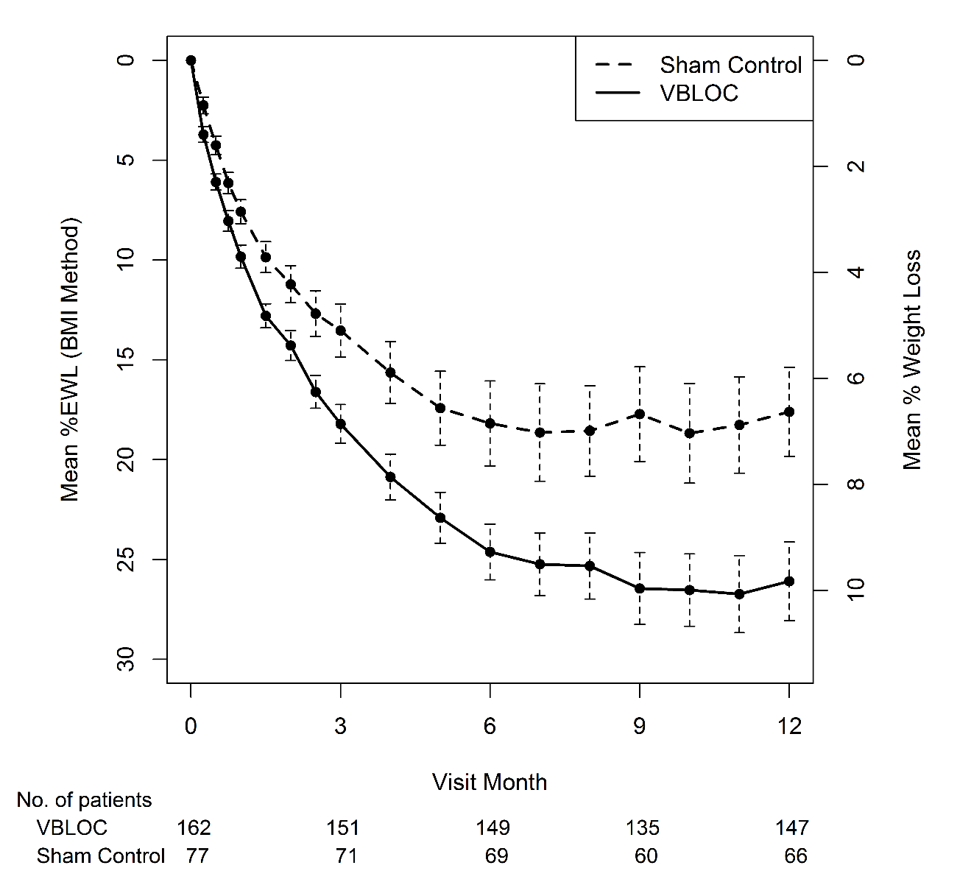

Figure 9‑1:  Mean %EWL and %TBL and Standard Errors without Imputation

### Responder Analyses

At 12 months in the ITT population, the VBLOC group had 52.5% of subjects with 20% or greater EWL and 38.3% of subjects with 25% or greater EWL, which did not meet the respective performance goals of 55% and 45%. The sham control group had 32.5% of subjects with 20% or greater EWL and 23.4% of subjects with 25% or greater EWL.

Responder analyses were conducted comparing the percentage of subjects in each group who achieved levels of response between 20% and 50%. As shown in Table 9‑7, there is a statistically significant treatment benefit over sham surgical control at all %EWL thresholds from 20% EWL and above. The difference in responder rates is also presented using odds ratios. The VBLOC group has significantly higher odds of achieving higher %EWL thresholds over sham control at every threshold from 20% and above.

Table 9‑7: %EWL Thresholds from Implant in ITT Population

| **%EWL Achieved** | **VBLOC N=162** | **Sham Control N=77** | **OR [95% CI]** |
| --- | --- | --- | --- |
| 20% EWL | 85 (52.5%) | 25 (32.5%) | 2.3 [1.3, 4.1] |
| 25% EWL | 62 (38.3%) | 18 (23.4%) | 2.0 [1.1, 3.8] |
| 30% EWL | 49 (30.2%) | 14 (18.2%) | 2.0 [1.0, 3.8] |
| 40% EWL | 35 (21.6%) | 4 (5.2%) | 5.0 [1.7, 14.7] |
| 50% EWL | 24 (14.8%) | 1 (1.3%) | 13.2 [1.8, 99.6] |

### Improvements in Obesity Risk Factors

Table 9‑8 illustrates the improvements seen in obesity risk factors for the VBLOC and sham control groups. All obesity risk factors trended toward improvement with VBLOC therapy and in the sham control group.

Improvements in patient questionnaires (i.e., IWQoL, Three Factor Eating Questionnaire) were also observed consistent with the weight loss.

Table 9‑8: Change in Obesity Risk Factors at 12 Months

| **Risk Factor** | **VBLOC** | | **Sham Control** | |
| --- | --- | --- | --- | --- |
| **Screening**  **Mean [95% CI]** | **Mean Change from Screening [95% CI]** | **Screening**  **Mean [95% CI]** | **Mean Change from Screening [95% CI]** |
| **Metabolic** |  |  |  |  |
| Total Cholesterol (mg/dL) | 204.2 [198.3, 210.2] | -8.7 [-13.5, -3.8] | 204.8 [196.5, 213.2] | -9.7 [-16.9, -2.6] |
| LDL Cholesterol (mg/dL) | 121.9 [116.8, 127.0] | -5.2 [-9.6, -0.9] | 122.5 [115.8, 129.2] | -4.3 [-10.2, 1.7] |
| HDL Cholesterol (mg/dL) | 54.3 [51.9, 56.6] | 1.0 [-0.5, 2.5] | 53.6 [49.3, 57.9] | -0.4 [-3.0, 2.3] |
| Triglycerides (mg/dL) | 141 [131, 151] | -21 [-31, -12] | 151 [127, 175] | -33 [-48, 18] |
| Fasting Plasma Glucose (mg/dL) | 96.6 [93.7, 99.5] | -1.5 [-4.1, 1.0] | 98.4 [89.8,106.9] | -0.7 [-3.5, 2.2] |
| HbA1c (%) | 5.66 [5.56, 5.77] | -0.33 [-0.40, -0.26] | 5.85 [5.52, 6.18] | -0.31 [-0.43, -0.20] |
| **Cardiovascular** |  |  |  |  |
| Systolic Blood Pressure (mmHg) | 127.4 [125.4, 129.4] | -5.5 [-7.8, -3.2] | 129.5 [126.3, 132.7] | -4.0 [-7.3, -0.7] |
| Diastolic Blood Pressure (mmHg) | 80.7 [79.2, 82.2] | -2.8 [-4.3, -1.2] | 81.5 [79.1, 84.0] | -4.5 [-6.5, -2.4] |
| Heart Rate (bpm) | 76.2 [74.7, 77.8] | -3.6 [-5.3, -1.9] | 74.8 [72.3, 77.3] | -3.5 [-6.3, -0.7] |
| **Anthropometric** |  |  |  |  |
| Waist Circumference (cm) | 121 [120, 123] | -10 [-12, -8] | 123 [120, 125] | -8 [-10, -6] |

## Updated Results through 18 Months

Complete data were collected on 159 subjects (117 VBLOC and 42 sham control) at 18 months. Since the trial remained blinded until all subjects had completed the 12-month visit, most subjects remained blinded for several months after the 12-month visit. The median time to unblinding was 16 months for both groups. Specifically, at 15 months, 84% of VBLOC subjects and 90% of sham control subjects (86% total) remained blinded. At 18 months, 27% of VBLOC subjects and 25% of sham control subjects (26% total) remained blinded.

Efficacy through 18 months was assessed using three statistical techniques: a mixed-effects regression model, the LOCF methodology, as well as without imputation. Results from the mixed-effects model suggest that weight loss with VBLOC therapy was durable, with an estimated mean 25.8% EWL at 12 months, 24.4% at 15 months, and 23.5% EWL at 18 months. The sham control group regained a significant amount of weight following the 12-month visit, with an estimated mean %EWL of 16.9% at 12 months, 12.9% at 15 months, and 10.1% at 18 months.

The treatment difference increased from 8.9 percentage points (95% CI: 4.3 to 13.5) at 12 months to 13.4 percentage points (95% CI: 8.4 to 18.4) at 18 months. This increase in relative efficacy as a result of the sham control group gaining weight cannot be largely attributed to unblinding since most subjects remained blinded until the 16-month visit.

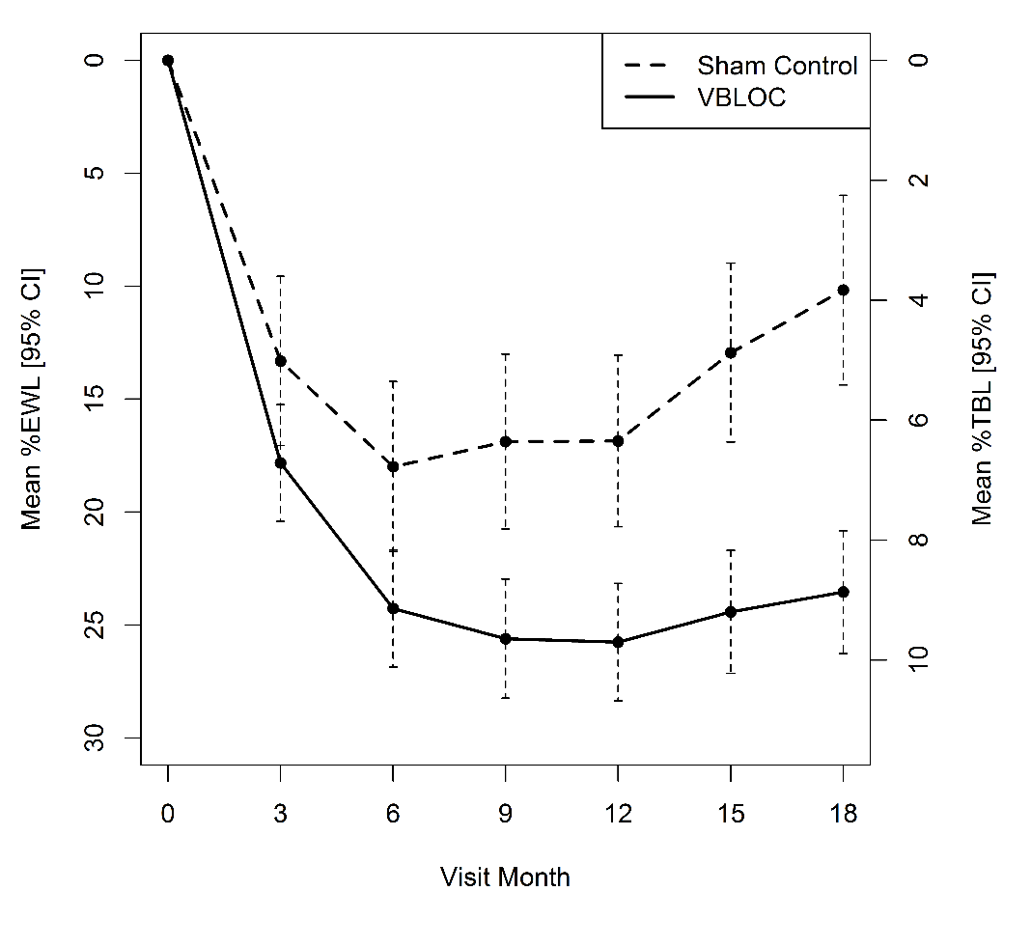

Figure 9‑2: Estimated Mean %EWL and 95% CI from Mixed-Effects Model through 18 months

The related SAE rate, the proportion of subjects in the VBLOC group who experienced an implant/revision procedure, device, or therapy-related SAE, was 4.3% (95% CI: 1.8 to 8.7) in the ITT population at 18 months. One additional related SAE was a gastric perforation that occurred in a female subject during explant of the device when she decided to discontinue study participation. The safety SAE rate through 18 months including those SAEs related to general surgical procedure was 9.3% (95% CI: 5.3 to 14.8) in the VBLOC group

Through 18 months there were no deaths or unanticipated adverse device effects (UADEs) with the Maestro Rechargeable System. The overall adverse event profile at 18 months was similar to that observed through 12 months.

# Individualization of Treatment

Best results are achieved when the patient is fully informed about the therapy risks and

benefits, surgical procedure, follow-up requirements, and self-care responsibilities.

Maximum benefits from the Maestro Rechargeable System require long-term management.

## Patient Selection

Select patients carefully to ensure that they are:

* Appropriate candidates for surgery;
* Can properly operate the system; and
* Have no known allergies to implantable components of the Maestro Rechargeable System.

## Use in Specific Populations

The safety and effectiveness of this therapy has not been established for:

* Pregnancy, unborn fetus, or delivery;
* Pediatric use (patients under the age of 18); or
* Patients with a history of bariatric surgery, fundoplication, gastric resection or major upper-abdominal surgery.

## Patient Counseling

Patients should be counseled on healthy eating, being active and how to lose weight and should be encouraged to participate in weight management sessions that are typically conducted in bariatric clinical settings.

# Operating Instructions

The Model 2200A and 2200P Leads are implanted onto the anterior and posterior vagal trunks just above the esophago-gastric junction. The Model 2200P Lead is intended for the posterior vagus, and is differentiated by a white suture wing and an embedded white stripe that runs the length of the lead. The Model 2200A Lead is intended for the anterior vagus, and has clear body tubing and a clear suture wing. Each lead is mechanically retained within the neuroregulator by means of set screws that also assure electrical contact. As shown in Figure 11‑1, the posterior lead receptacle on the neuroregulator header with a white septum, also identified with a P on the neuroregulator enclosure, is for connection with the white posterior lead. The neuroregulator receptacle with a clear septum, also identified with an A on the neuroregulator enclosure, is intended for connection with the clear anterior lead. Each lead has silicone rubber insulation, flexible conductors, and platinum iridium electrodes. Each lead has at least two types of suture fixation, a suture tongue at the distal end of the lead, and a suture wing on the lead body.

The Model 2002 rechargeable neuroregulator may be placed subcutaneously in one of the following locations:

1. Mid-axillary line of the thorax
2. Location determined by the surgeon and consistent with device operation.

The neuroregulator should be implanted between 2 and 3 cm below, and parallel to, the surface of the skin.

**Note:** The neuroregulator must be placed **not** **deeper than 4 cm** below the surface of the skin to ensure efficient charging and good communication between the mobile charger and the neuroregulator.

The neuroregulator can be identified by an x-ray marker (EM2). Figure 11‑2 shows the Model 2200 leads and the Model 2002 neuroregulator.

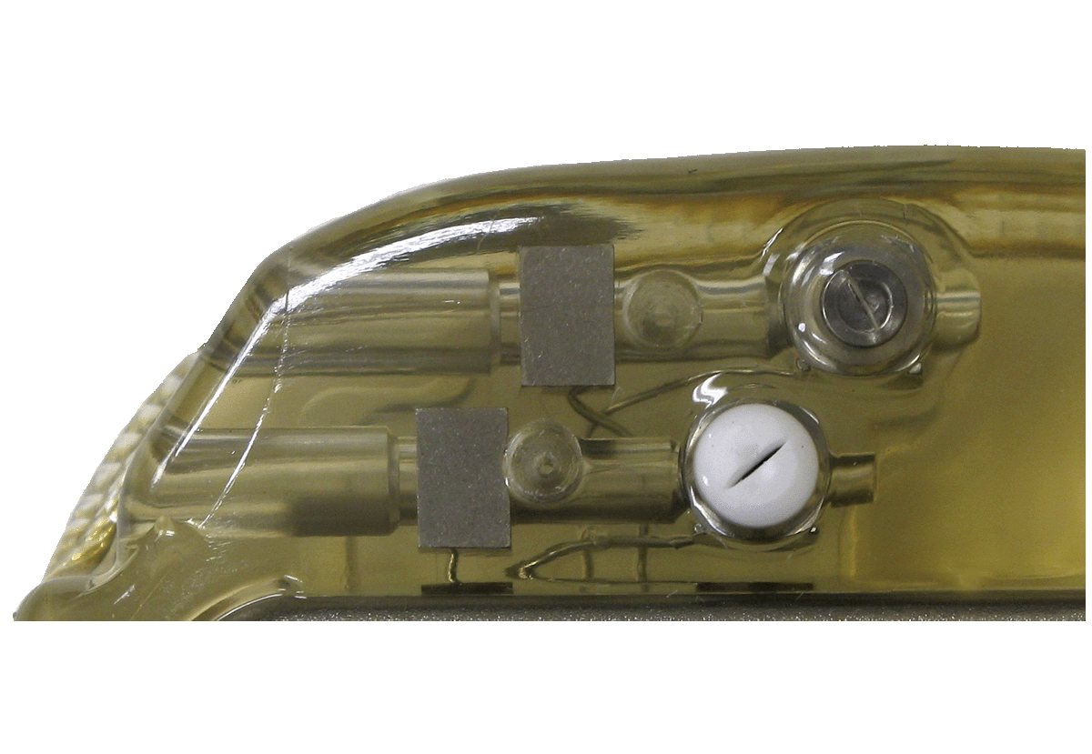**Figure 11‑1:** **Neuroregulator Header**

Anterior Lead Setscrew Septum

Posterior Lead Setscrew Septum

Pressure Relief Holes

Figure 11‑2: Neuroregulator and Leads

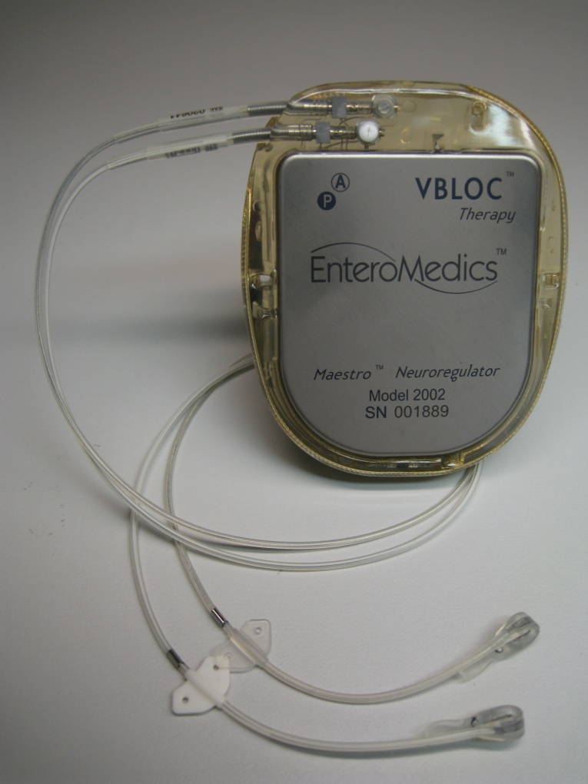

Nerve Electrode

Suture Tongue

Suture Holes (3)

Suture Wing

Setscrews

Anterior Lead Socket Indicator

Posterior Lead Socket Indicator

Ring Electrode

The Model 2403-60 patient transmit coil (Figure 11‑3), with a cable length of 60 cm, will be provided to the patient for daily use with the Maestro Rechargeable System. The Model 2403-300 clinician transmit coil is used during the surgical procedure and has a cable length of 300 cm to allow the transmit coil to be used within the sterile field using a sterile sleeve.

Figure 11‑3: Model 2403-60 Transmit Coil

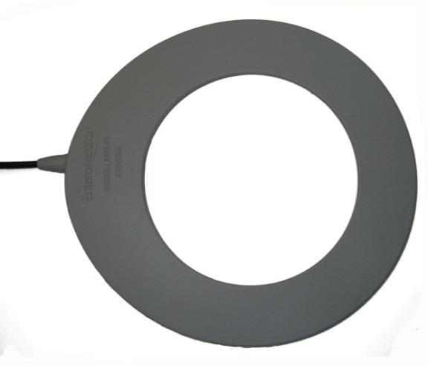

The Model 2402 mobile charger (Figure 11‑4) is an electronic device used externally by the patient during recharging of the neuroregulator. The major function of the mobile charger is to provide the power necessary to recharge the battery inside the neuroregulator and provide a communications path between the clinician programmer and the neuroregulator. The mobile charger is also powered by a non-replaceable lithium ion rechargeable battery.

Figure 11‑4: Mobile Charger

Transmit Coil

&

AC Recharger Port

Display

Clinician Programmer Port

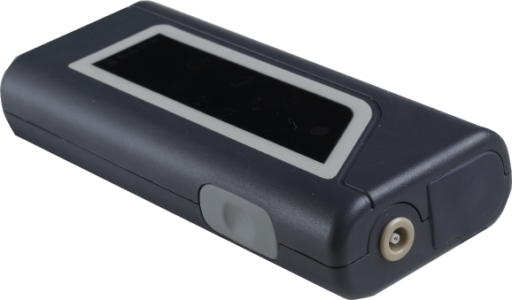

Button

Figure 11‑5: Mobile Charger – Display Detail

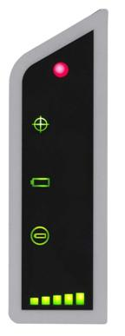

Neuroregulator Battery Icon

Mobile Charger Battery Icon

Transmit Coil Position Icon

Status Icon

Bar Graph

The Model 2502 clinician programmer enables the clinician to configure and change therapy parameters and the treatment schedule in the neuroregulator. It provides a graphical user interface to help the clinician monitor the performance of the Maestro Rechargeable System and patient compliance with device charging. In addition, the clinician programmer provides access to the Maestro Rechargeable System manuals.

The clinician programmer is connected to the Model 2402 mobile charger with the Model 1600 programmer cable, as shown in Figure 11‑6. This cable connects to a standard USB port on the clinician programmer and the clinician programmer port on the mobile charger.

**Figure 11‑6: Connecting the Mobile Charger & Clinician Programmer**

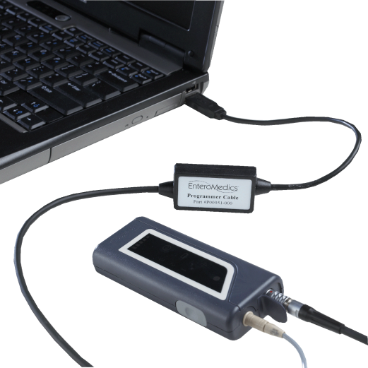

USB Connection on the Clinician Programmer

Clinician Programmer Port

Transmit Coil

&

AC Recharger Port

## Using the Mobile Charger

**Preparing the Mobile Charger for Initial Use**

The mobile charger is shipped in an inactive state. Press and release the button on the mobile charger **once** to make it operational and wait a few seconds until the display icons illuminate in sequence. Once operational, the mobile charger will shut off after several minutes of inactivity to preserve battery longevity. The mobile charger will automatically turn on when the button is pressed.

The mobile charger should be charged, using the AC recharger, for a minimum of 8 hours prior to initial use. See the “Patient Operating Instructions” section of this manual for instructions on charging the mobile charger.

**Positioning the Transmit Coil over the Neuroregulator**

Finding the best position of the transmit coil over the neuroregulator is important to ensure efficient charging and good communication between the mobile charger and the neuroregulator.

Insert the transmit coil connector into the transmit coil port on the top side of the mobile charger (Figure 11‑4). The transmit coil position icon will be illuminated as indicated in Figure 11‑5.

With the transmit coil held away from the implanted neuroregulator, **press and hold** the mobile charger button (Figure 11‑4) for approximately two seconds until the transmit coil position icon starts to flash and the bar graph is illuminated (Figure 11‑5).

Begin positioning the transmit coil by sweeping the transmit coil across the neuroregulator in all directions, keeping the coil close to the body. The number of illuminated bars on the bar graph indicator will increase and decrease.

Position the transmit coil to maximize the number of bars on the bar graph. One bar indicates poor transmit coil position and five bars indicate the best transmit coil position.

Secure the transmit coil in the best position using the belt provided or another clinician approved method. Press the button once to accept this position.

Once the transmit coil position has been accepted, the transmit coil position icon will turn off.

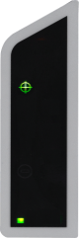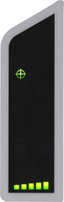

Poor Signal Strength

Strong Signal Strength

Coil Position Indicator

**Note:** If the transmit coil becomes displaced, the mobile charger will automatically illuminate the transmit coil position icon. The coil should be repositioned as described above.

**Note:** Always hold on to the connector when connecting and disconnecting the transmit coil. **Do not pull on the cable** to unplug the transmit coil connector from the mobile charger.

## Maestro Rechargeable System Preparation Prior to Implantation

**Neuroregulator Placement**

It is important to assess placement of the neuroregulator **prior to surgery.** Assess the placement with the patient in both the sitting and standing positions, to ensure patient comfort, efficient charging and good communication between the mobile charger and the neuroregulator. Discuss with the patient the device placement in the following order of preference:

* 1. Mid-axillary line of the thorax.
  2. Location determined by the surgeon and consistent with device operation.

**Mobile Charger Preparation**

The day prior to the implant procedure two mobile chargers should be fully charged following the instructions in “Patient Operating Instructions” of this manual.

**Entering Registration Information on the Clinician Programmer**

On or before the day of surgery, registration information must be entered.

**Note:** During surgery, the lead status (impedance) test must be performed to verify correct placement of the leads. This test cannot be performed until the patient registration is complete.

**Note:** When the clinician programmer is used by a physician for the first time, it is recommended that physician information is entered. For more information, see the Clinician Programmer Manual.

To register a new patient:

1. Connect the clinician programmer to the patient’s mobile charger with the transmit coil properly located over the neuroregulator.

**Note:** Registration may be performed with theneuroregulator in the sterile package. Place the transmit coil over the sterile packed neuroregulator in a position with at least four bars on the bar graph display of the mobile charger.

**Note:** For best communication between the clinician programmer and neuroregulator, avoid any metal objects within three centimeters from the sterile packed neuroregulator.

1. If the clinician programmer is communicating with the mobile charger and neuroregulator, the “Registration” screen (Figure 11‑7) will be displayed. This screen may also be displayed by selecting the “Registration” icon.
2. Select the “Physicians” tab from the “Registration” screen (Figure 11‑8). Check the appropriate name on the physician list. If the physician’s name is not on the list, enter the required information and press “Save Physician” to record the information.
3. Select the “Patient Registration” tab from the “Registration” screen (Figure 11‑7) and enter the required information. Press “Save Patient” to record the information.

**Note:** The clinician programmer will automatically enter the serial numbers of the mobile charger and neuroregulator. The serial numbers of the leads must be entered manually and must be re-entered any time the leads are replaced.

1. Check the battery charge level of the neuroregulator and recharge if necessary. For more information see “Charging the Battery in the Neuroregulator” section of this manual.

**Note:** The clinician programmer will record the date when patient registration data is saved for the first time as the date of implant. If the registration information is entered before the day of surgery, the implant date must be manually updated.

**Note:** For detailed instructions on how to use the clinician programmer, consult the Clinician Programmer Manual.

Figure 11‑7: Registration Screen – Patient Registration

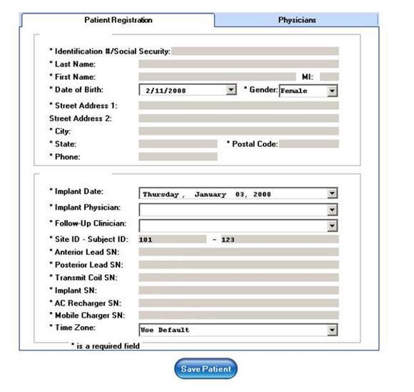

Figure 11‑8: Registration Screen – Physician Information

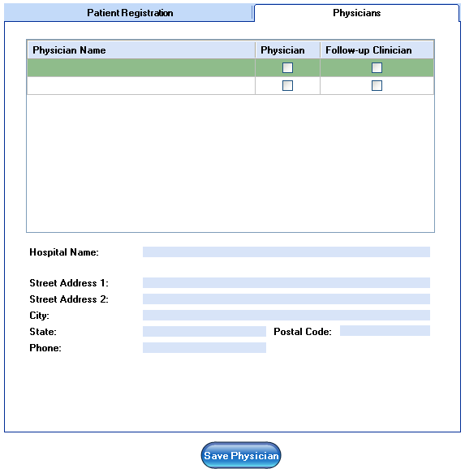

# Implant Procedure Summary

**Note**: Please see Maestro Rechargeable System Surgical Implant Procedure for detailed instructions.

1. Prepare the patient for laparoscopic surgical placement of leads on the anterior and posterior vagal nerve trunks.
2. Use standard laparoscopic technique to expose the intra-abdominal anterior and posterior vagal trunks near the esophago-gastric junction.
3. During insertion through a trocar (minimum size 12 mm) the lead should be handled without grasping or distorting the electrodes. Once inserted, **grasp only** the suture tongue and/or the suture wing (Figure 11‑2) of the lead. Avoid lead withdrawal through the trocar.
4. Place the white-striped lead (2200P) on the posterior trunk. Use the suture tongue to position the nerve electrode under the nerve. Anchor the lead by suturing the suture tongue to the esophagus adjacent to the nerve.
5. Place the anterior lead with no stripe (2200A) on the anterior trunk. Use the suture tongue to position the nerve electrode under the nerve. Anchor the lead by suturing the suture tongue to the esophagus adjacent to the nerve.
6. Provide strain relief for each lead by suturing both sides of the suture wing close to the esophago-gastric junction on the stomach. This allows for electrical contact of the ring electrode to provide for diagnostic measurements of the system. Leave sufficient lead length between the suture wing and suture tongue for each lead to prevent tension on the nerve.
7. Verify that the nerves are properly seated within the electrodes.
8. Ensure that the suture through the suture hole of the suture tongue is firmly anchoring the lead.
9. Externalize the leads by carefully withdrawing the lead connectors through a trocar (minimum size 12 mm) adjacent to the site of lead connection. Extra lead length may be gently pulled back into the abdominal cavity after connections to the neuroregulator are made.
10. Create a pocket for the neuroregulator subcutaneously in the following order of preference:
11. Mid-axillary line of the thorax.
12. Location determined by the surgeon and consistent with device operation.

The neuroregulator is positioned (with suture) at a depth between 2 and 3 cm below the surface of the skin.

**Note:** The neuroregulator must be placed **not** **deeper than 4 cm** below the surface of the skin to ensure efficient charging and good communication between the mobile charger and the neuroregulator.

1. Ensure that the neuroregulator lead sockets are open by using the provided torque wrench and back the setscrews out for three or more turns.
2. Insert the posterior lead (with white markings) into the posterior neuroregulator socket (white septum). Verify that the lead is fully inserted by visually identifying that the lead connector extends past each setscrew septum (Figure 12‑1). Tighten the setscrew to two clicks using the provided torque wrench.
3. Insert the unmarked anterior lead into the anterior neuroregulator socket (clear septum). Verify that the lead is fully inserted by visually identifying that the lead connector extends past each setscrew septum (Figure 12‑1). Tighten the setscrew to two clicks using the provided torque wrench.
4. Perform a lead status (impedance) test as described in the “Lead Status (Impedance) Test in Surgery” section and ensure that the impedance values are in the allowable range.
5. Use medical adhesive to seal the two pressure relief holes and the two septums in the neuroregulator header. Figure 12‑1 is a picture of the neuroregulator header prior to medical adhesive application and Figure 12‑2 is a picture of the neuroregulator after medical adhesive is applied.
6. Use all three suture holes to secure the neuroregulator to the muscular fascia. This prevents device migration and helps to maintain position approximately parallel to the skin surface.
7. Perform another lead status (impedance) test as described in the “Lead Status (Impedance) Test in Surgery” section.
8. The leads should be routed **straight out** from the neuroregulator and should exit the pocket without forming any loops around the neuroregulator. Do not leave any excess lead length in the pocket. This will facilitate safe operation of the system during charging.
9. Close all incisions.
10. Perform the final lead status (impedance) test as described in the “Lead Status (Impedance) Test in Surgery” section.
11. Activate the device and initiate therapy as described in the “Device Activation and Treatment Initiation during Surgery” section.

Figure 12‑1: Lead Connection to the Neuroregulator Prior to Medical Adhesive Application

Pressure Relief Holes

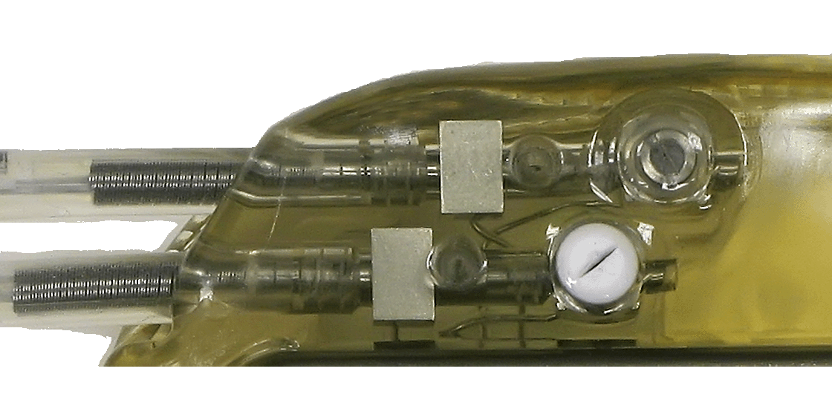

Posterior Lead Tip

Anterior Lead Tip

Figure 12‑2: Lead Connection to the Neuroregulator after Medical Adhesive Application

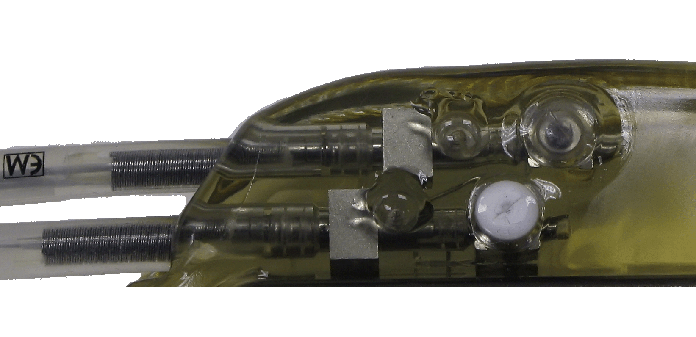

Setscrew Septums

Pressure Relief Holes

# Lead Status (Impedance) Test in Surgery

**Note**: The lead status (impedance) test should be conducted only when the retractors are removed and after carbon dioxide insufflation.

**Note:** The lead status (impedance) test cannot be performed until the patient registration is complete.

**Note:** During surgery, the lead status (impedance) test should be conducted with the default amplitude of 3mA. After the final test is complete the lead impedance amplitude must be reprogrammed to1 mA and saved. During the first follow-up visit, the lead impedance test amplitude must be reprogrammed to 3 mA and saved.

* + - 1. Place the clinician transmit coil in a sterile sleeve.
      2. Connect the clinician transmit coil to the mobile charger.
      3. Connect the mobile charger to the clinician programmer using the programmer cable.
      4. Properly position the clinician transmit coil over the neuroregulator.

**Note:** With the neuroregulator outside the pocket, the best location for the transmit coil may be found 1 or 2 cm above the neuroregulator.

* + - 1. Use the clinician programmer to perform the lead status (impedance) test. The “Diagnostic” screen (Figure 13‑1) displays the impedance values. A green check icon will be shown for each lead configuration if the impedance measurement is in the therapy delivery range (Table 13‑1).

**Note:** The desirable range for the lead impedance values directly after the surgical procedure is between 400 and 1000 Ohms.

* + - 1. If the lead status is not acceptable or the impedance is greater than 1000 Ohms, the following should be considered:

1. Check the setscrew connections for each lead to the neuroregulator.
2. Clear all fluids from nerve electrodes.
3. Reposition, re-suture, or replace leads as appropriate.

**Note:** If the lead status (impedance) test could not be performed, reposition the transmit coil as described above and repeat the test.

**Note:** Therapy will not be delivered at impedance levels below 400 Ohms and above 1500 Ohms (Table 13‑1).

Figure 13‑1: Lead Status (Impedance) Test

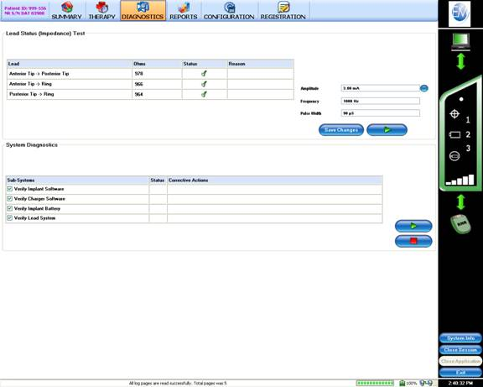

Table 13‑1: Lead Impedance Measurements

|  |  |  |
| --- | --- | --- |
| **Low Impedance (Short Circuit)** | **Acceptable Impedance Range** | **High Impedance (Open Circuit)** |
| <400 Ohms | 400 – 1500 Ohms | >1500 Ohms |
| Therapy Delivery Disabled | Therapy Delivery Range | Therapy Delivery Disabled |
| Electrodes may be in contact with each other or too close together. | Impedances between 400 and 1000 Ohms are desirable.  Impedances may change within the first several days or weeks following lead implantation. | Contact between electrodes and the nerve may be insufficient or the lead may be damaged and should be replaced. |

# Device Activation and Treatment Initiation during Surgery

## Device Activation and Therapy Initiation

During surgery, the device will be activated and the initial treatment parameters set.

**Note:** Refer to the Clinician Programmer Manual for additional information regarding clinician programmer functions.

The clinician programmer and the mobile charger are used to activate the device and establish the therapy parameters and therapy delivery schedule:

1. Connect the mobile charger to the clinician programmer using the programmer cable.
2. Connect the transmit coil to the mobile charger and properly position the transmit coil.

**Note:** If the clinician programmer message “Device Activation Needed” appears, select “OK” and confirm when “Please Confirm Device Activation” is displayed.

1. Ensure the clinician programmer is in communication with the mobile charger and the neuroregulator by observing the dashboard on the “Summary” screen.
2. Select “Diagnostics” from the “Summary” screen to open the “Diagnostic” screen.
3. Perform a lead status (impedance) test.
4. Ensure that the Anterior to Posterior impedance is in the acceptable impedance range (400-1500 Ohms). If the lead status test is not acceptable, contact EnteroMedics.
5. Select “Therapy” from “Summary” screen to open the “Therapy” screen.

**Note:** If the clinician programmer message “Device Activation Needed” appears, select “OK” and confirm when “Please Confirm Device Activation” is displayed.

1. Ensure the therapy settings for parameter set 1 are “Enabled” and parameter sets 2 and 3 are “Disabled”.
2. The default therapy settings for parameter set 1 are the following:
   * Amplitude: 1.0 mA
   * Frequency 5000 Hz
   * Pulse Width 90 uS
   * Ramp Up 20.0 S
   * Ramp Down 0.0 S
   * ON Time: 5.0 Min: 2 ON/1 OFF
   * OFF Time: 5.0 Minutes
   * Lead Configuration: “Ant to Post”
3. Start the Real Time Test as shown in Figure 14‑1. Stop the Real Time Test after a few minutes when therapy delivery is shown on the Real Time Test screen.

**Note:** When the Therapy Timing is programmed to 5 minutes ON, the actual therapy the Maestro Programmable System will deliver consists of 2 minutes ON, 1 minute OFF, 2 minutes ON, followed by the Therapy OFF time, as shown in Figure 14‑1)

Figure 14‑1: Real Time Test

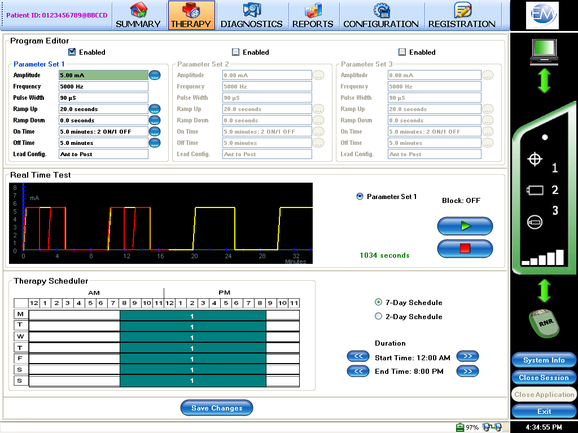

Start Real Time Test

Stop Real Time Test

1. Adjust the therapy schedule if needed to deliver the prescribed hours of therapy (Figure 14). Select “Save Changes” after the therapy schedule and parameters have been established.

**Note:** It is recommended to adjust the therapy schedule to 13 hours of therapy delivery during hours when the patient is awake.

12 Select the “Diagnostics” Screen to change the lead impedance test amplitude to 1 mA and save the changes (Figure 14‑2).

Figure 14‑2: Therapy Scheduler

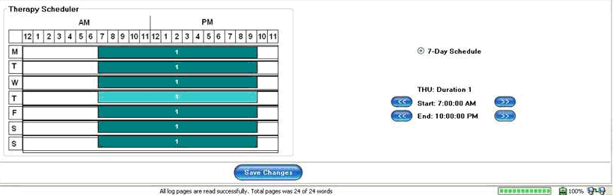

Note: The patient should be instructed on the use of the mobile charger and how to charge the mobile charger and neuroregulator before leaving the clinician’s office. The patient should also be instructed to contact the clinician’s office if there are any questions or unacceptable treatment related events.

## Post Implant Healing Period

In the post-operative period, some patients may experience a temporary drop in lead impedance due to the healing process. This can result in impedance related events that can suspend scheduled therapy delivery. During the first 11 days following therapy activation, the Maestro Rechargeable System will suppress impedance related indications and suspend scheduled therapy if any impedance related events occur. This feature is intended to prevent undue patient concern and unnecessary clinic visits from impedance related events due to the healing response.

Impedance related events will be cleared and scheduled therapy will be automatically resumed once the 11 day period has elapsed.

If a clinic follow up visit occurs within the 11 days following therapy activation, impedance related events will be cleared and normal operation will resume for the duration of the clinician programmer session. When the session is closed, the system operation for the 11 days following therapy activation as described above will resume.

# Modifying Therapy Parameters during Follow-Up Visits

The therapy may be adjusted during subsequent follow up visits using the mobile charger and clinician programmer:

1. Ensure the clinician programmer is connected to the mobile charger via the programmer cable and the patient transmit coil is in proper alignment over the neuroregulator.

**Note:** The connection between the neuroregulator, mobile charger, and clinician programmer can be verified in the dashboard on the “Summary” screen of the clinician programmer.

1. Select “Diagnostics” from the “Summary” screen to open the “Diagnostic” screen.
2. Perform a lead status (impedance) test. If the lead status test is not acceptable, contact EnteroMedics.
3. Select “Therapy” from the “Summary” screen to open the “Therapy” screen.
4. The clinician may adjust the following settings as necessary:
   1. Amplitude
   2. Ramp Up Time
   3. Therapy Schedule
5. Start the Real Time Test to confirm the patient can tolerate the therapy settings.
6. Select “Save Changes” after the therapy schedule and parameters have been established.

## First Follow-Up Visit

During the first follow up visit, the lead impedance test amplitude must be changed from 1 mA programmed at surgery, to 3mA, using the “Diagnostics” Screen.

Use the “Therapy” Screen (Figure 15‑1) to increase the therapy amplitude to the maximum the patient can reasonably tolerate up to 3mA. The ramp time may be adjusted to improve patient tolerance of the therapy. Re-run the Real Time Test to confirm the patient can tolerate the therapy settings. Save the changes.

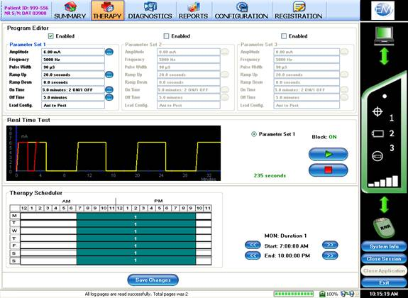Figure 15‑1: Therapy Screen

## Successive Follow-Up Visits

In order to maximize therapy, the proposed therapy setting will be at the maximum therapy amplitude which the patient can reasonably tolerate with a therapy ON time of five minutes. Therapy amplitude may be lowered based on patient tolerance. The ramp time may be increased to improve patient tolerance of the therapy.

At each successive follow up, the capacity of the rechargeable battery in the neuroregulator must be checked using the neuroregulator Battery Diagnostic Report (Figure 15‑3) and the Therapy Delivery Report (Figure 15‑2). When the capacity of a fully charged battery becomes insufficient for delivering the daily programmed hours of therapy, the neuroregulator is approaching its end of life and replacement should be considered. The neuroregulator Battery Diagnostic Report shows the frequency of charging the neuroregulator battery and the Therapy Delivery Report shows the delivered hours of therapy and occurrence of a low battery status. Neuroregulator replacement should be considered when the neuroregulator battery is fully charged once per day, however the programmed therapy hours for one day frequently cannot all be delivered and a low neuroregulator battery status is reported daily as indicated in the Therapy Delivery Report.

Figure 15‑2: Therapy Delivery Report

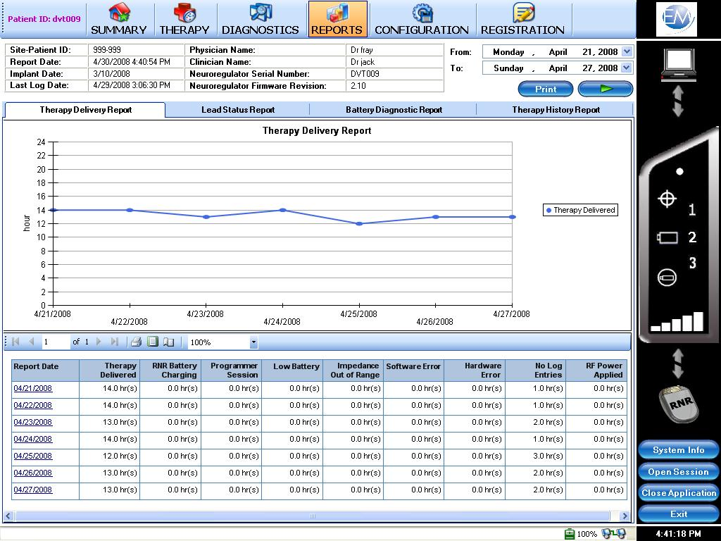

Figure 15‑3: Battery Diagnostic Report

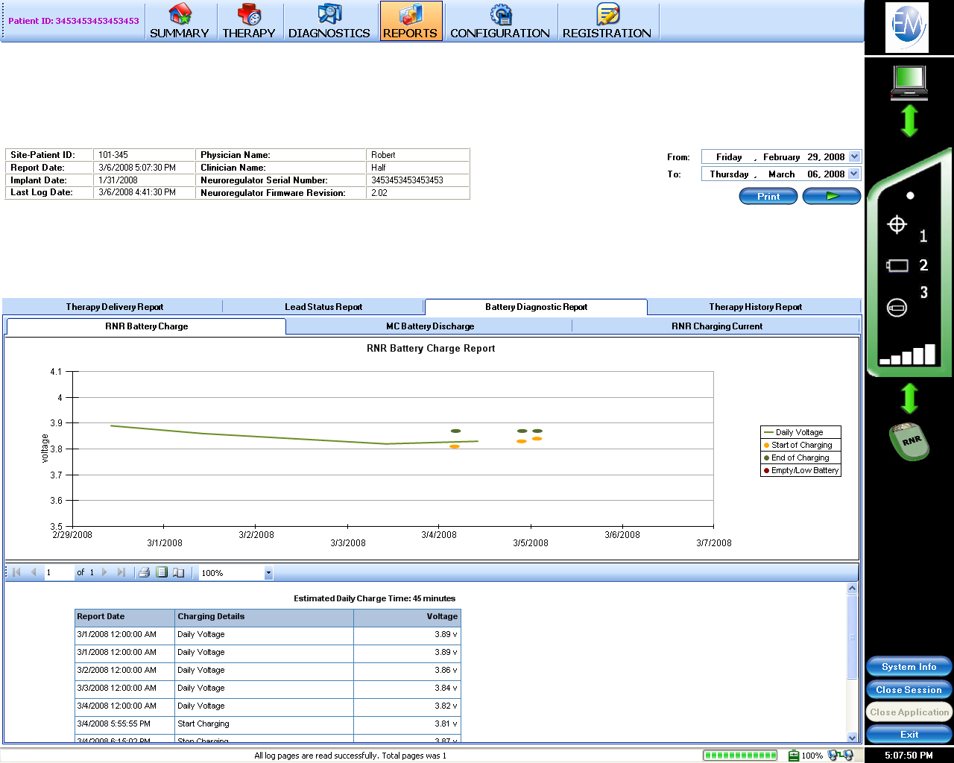

## Maestro Rechargeable System Reports

The clinician programmer may be used to display the following reports:

* Therapy Delivery
* Neuroregulator Battery Charge
* Mobile Charger Battery Discharge
* Lead Status
* Therapy History

Refer to the Clinician Programmer Manual for additional information on these reports.

# Maintaining the Maestro Rechargeable System

## Maintaining the Neuroregulator

If an activated neuroregulator is not recharged within a period of two months, the battery within the neuroregulator may lose its capacity to be recharged and may no longer be capable of delivering therapy.

If a patient and/or clinician make the decision to stop therapy, the neuroregulator battery must be recharged fully. Use the clinician programmer to display the battery voltage. A fully recharged battery will be greater than 3.85 V. The neuroregulator must then be turned off. This can be accomplished by **pressing and holding** the button on the mobile charger for more than 60 seconds until the display flashes the red status icon (Figure 11‑5). A yearly visit to check the battery charge level and to recharge the neuroregulator is required.

A deactivated neuroregulator may be reactivated by the clinician using the clinician programmer. Please see the Clinician Programmer Manual for more details.

**Note:** When reactivating a neuroregulator, the clinician should check if the mobile charger and the transmit coil of the patient are still operational. A new mobile charger may be required if the patient has not recharged its battery during the time of neuroregulator deactivation.

**Note:** The clinician should instruct patients about regularly recharging the neuroregulator, about the risks of leaving an active neuroregulator uncharged for more than two months and about the option to deactivate the device.

## Maintaining the Mobile Charger and Transmit Coil

Clean the transmit coil and mobile charger when needed by using a damp soapy cloth. Do not immerse the mobile charger or transmit coil in any liquid. Do not allow water to enter into the connectors. Use a damp cloth to remove any soap residue. Allow components to dry prior to use. One time per month, inspect the mobile charger and transmit coil for wear or damage. Please contact EnteroMedics should replacement components be required.

# Patient Operating Instructions

**Charging the Battery of the Mobile Charger**

To charge the mobile charger, connect the AC recharger to a power outlet. Then connect the AC recharger to the AC recharger port on the mobile charger (Figure 4). The indicator light on the AC recharger will be illuminated (orange or green).

**Note:** If the indicator light on the AC recharger is not illuminated, check if the AC recharger is connected correctly to a wall outlet and the wall outlet is switched on.

The mobile charger battery icon will be illuminated and the bar graph (Figure 11‑5) will flash sequentially from left to right, indicating that the battery is being charged.

**Note:** If the bar graph on the mobile charger does not illuminate, check if the AC recharger is connected correctly to the mobile charger and press the button.

**Note:** If the mobile charger has not been charged for an extended period of time, the mobile charger battery icon may not be illuminated. Leave the mobile charger connected to the AC recharger for half an hour, then press the button on the mobile charger again.

During charging, the indicator light on the AC recharger will be orange and will turn green when charging is complete. The mobile charger battery icon and the bar graph will continue to flash sequentially from left to right even when recharging is complete. It is recommended to leave the mobile charger connected after it is fully recharged until it is used. This will keep the battery fully charged and will not harm the mobile charger.

**Note**: Use only the AC recharger provided by EnteroMedics to recharge the mobile charger.

## Positioning the Transmit Coil over the Neuroregulator

Finding the best position of the transmit coil over the neuroregulator is important to ensure efficient charging and good communication between the mobile charger and the neuroregulator.

Insert the transmit coil connector into the transmit coil port on the top side of the mobile charger (Figure 11‑4). The transmit coil position icon will be illuminated as indicated in Figure 11‑5.

With the transmit coil held away from the implanted neuroregulator, **press and hold** the mobile charger button (Figure 11‑4) for approximately two seconds until the transmit coil position icon starts to flash and the bar graph is illuminated (Figure 11‑5).

Begin positioning the transmit coil by sweeping the transmit coil across the neuroregulator in all directions, keeping the coil close to the body. The number of illuminated bars on the bar graph indicator will increase and decrease.

Position the transmit coil to maximize the number of bars on the bar graph. One bar indicates poor transmit coil position and five bars indicate the best transmit coil position.

Secure the transmit coil in the best position using the belt provided or another clinician approved method. Press the button once to accept this position.

Once the transmit coil position has been accepted, the transmit coil position icon will turn off.



Poor Signal Strength

Strong Signal Strength

Coil Position Indicator

**Note:** If the transmit coil becomes displaced, the mobile charger will automatically illuminate the transmit coil position icon. The coil should be repositioned as described above.

**Note:** Always hold on to the connector when connecting and disconnecting the transmit coil. **Do not pull on the cable** to unplug the transmit coil connector from the mobile charger.

## Checking Neuroregulator and Mobile Charger Battery Charge Levels

Position the transmit coil over the neuroregulator as described above. With the transmit coil position icon off, press the button on the mobile charger once to display the battery level of the neuroregulator. The neuroregulator battery icon will be displayed and the bar graph will indicate the charge level of the neuroregulator (Figure 17‑1).

While the bar graph is still illuminated, press the button for a second time. The mobile charger battery icon will become illuminated and the bar graph will indicate the charge level of the mobile charger (Figure 17‑1).

**Note:** When the first segment of the bar graph is flashing, the battery must be recharged immediately.

**Note:** The mobile charger battery should be fully charged before attempting to recharge the neuroregulator.

**Figure 17‑1: Battery Charge Level Examples**

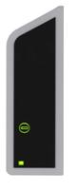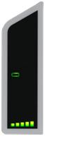

**Mobile Charger Battery   
is Fully Charged**

**Neuroregulator** **Battery  
Needs Recharging**

## Charging the Battery in the Neuroregulator

Position the transmit coil over the neuroregulator and check the battery charge level of the neuroregulator as described above. If the bar graph shows five segments, the neuroregulator is fully charged. No further charging is possible.

**Note:** The battery charge levels of the neuroregulator should be checked daily. It is recommended to charge the neuroregulator when the bar graph shows four segments. This will take approximately 30 minutes with proper coil placement.

**Note:** If the neuroregulator is charged when the bar graph shows less than four segments, charging may take up to three hours.

Before recharging the neuroregulator, check if the mobile charger is fully charged and recharge if necessary.

To start recharging the neuroregulator battery, **press and hold** the button while the neuroregulator battery charge level is displayed. **Release the button** when the bar graph begins to flash sequentially. The bar graph will continue to flash sequentially while the neuroregulator is being charged.

The battery is fully recharged when the neuroregulator battery icon illuminates and the bar graph flashes five segments once every five seconds. The neuroregulator cannot be overcharged.

**Note:** The mobile charger case may become warm during charging of the neuroregulator. While charging, place the mobile charger in a position that allows air circulation, do not lie in bed, sleep, sit or lie on the mobile charger, place the mobile charger in clothing or place the mobile charger within a carrying case.

**Note:** If the transmit coil becomes displaced, the mobile charger will automatically illuminate the transmit coil position icon. The coil should be repositioned as described above.

**Note:** If a neuroregulator is not charged within a period of two months, the battery within the neuroregulator may lose its capacity to be charged and may no longer be capable of delivering therapy.

**Note:** The patient must be instructed to fully charge the batteries of the neuroregulator and mobile charger before visiting with their clinician.

## Restoring the Mobile Charger’s Default Settings

The mobile charger’s default settings may be restored by **pressing and holding** the button for more than 15 seconds until the display icons illuminate in sequence.

## System Alerts

A status icon which is illuminated red, either continuously or intermittently, indicates that the system is not delivering therapy (Figure 11‑5). A red status icon does not indicate an emergency condition. It just indicates that therapy is not delivered. The patient should be instructed to contact their clinician during normal business hours to schedule an appointment.

# Deactivating the Neuroregulator

If required for deactivation or in an emergency situation, the neuroregulator may be turned off. Position the transmit coil over the neuroregulator using instructions above, **press and hold** the button on the mobile charger for approximately 60 seconds until the display flashes the red status icon. If a mobile charger is not available, the neuroregulator may be turned off by moving a medical device magnet over neuroregulator. Medical device magnets are commonly found in emergency rooms.

A deactivated neuroregulator may be reactivated by the clinician using the clinician programmer; please see the Clinician Programmer Manual for more details. Therapy is not delivered when the neuroregulator is deactivated. Deactivation should only be performed to preserve the rechargeable battery in the neuroregulator or in an emergency situation.

**Note:** When reactivating a neuroregulator, the clinician should check if the mobile charger and the transmit coil of the patient are still operational. A new mobile charger may be required if the patient has not charged the battery during the time of neuroregulator deactivation.

**Note:** The clinician should instruct patients about regularly charging the neuroregulator, about the risks of leaving an active neuroregulator uncharged for more than two months and about the option to deactivate the device.

# Implant Removal and Disposal Instructions

## Device Removal Training

Surgeons are required to complete training and receive certification on completion of the surgical explantation of the Maestro Rechargeable System prior to explanting a Maestro Rechargeable System.

## Removal of All Implantable Device Components

Following are the general instructions for explant of the implantable device components. Refer to EnteroMedics Surgeon Certification Training Program for detailed instructions.

* 1. Prepare patient for a standard laparoscopic surgical approach
  2. Retract the liver
  3. Identify lead bodies and follow down until the suture wings are identified on each of the two leads.
  4. Dissect along each lead towards the electrode.
  5. Grasp electrodes and lift off of nerve. Rotate electrode away from nerve to expose suture tongue.
  6. Cut suture tongue to free electrode.
  7. Free the suture wings.
  8. Cut lead bodies as they enter abdominal cavity from the neuroregulator and remove lead bodies from abdomen.
  9. Surgically open the subcutaneous neuroregulator pocket.
  10. Cut the sutures that secure the neuroregulator in position.
  11. Remove the neuroregulator from pocket along with the remaining portion of the leads that were inserted into the neuroregulator.
  12. Verify that all system components have been removed.
  13. Close all incisions.

**Note:** If removal of a lead poses a risk to the patient preventing its safe removal, the lead may be left in situ, but only in its entirety as described below.

Surgeons are strongly recommended to remove the entire lead, including the electrode, during an Implant Removal procedure. In the event removal of a lead poses a patient risk, the lead should be left in place in its entirety, and covered with a sterile silicone end cap designed for 3.2 mm diameter connector pins. Specifically the Oscor VS-32 End Cap should be used to cap the lead according to its instructions for use. A non-absorbable suture should be placed around the O-ring on the cap to secure it to the lead. A suture should then be applied around the silicone end cap and anchored in the subcutaneous pocket to secure the lead. Please refer to the EnteroMedics Surgeon Certification Training Program for detailed instructions.

**Note:** The lead should never be transected if it is to remain implanted. If a lead has been transected it should be completely removed.

## Replacement of Neuroregulator

Following are the general instructions for removal and replacement of the neuroregulator. Refer to EnteroMedics Surgeon Certification Training Program for detailed instructions.

* 1. Prepare patient for a standard laparoscopic surgical approach. Note: The abdomen may not need to be accessed for most neuroregulator replacement procedures.
  2. Surgically open the subcutaneous neuroregulator pocket. Care should be taken when opening the subcutaneous pocket to proceed in a lateral to medial direction. This is to avoid damaging the lead bodies.
  3. Cut the sutures that secure the neuroregulator in position.
  4. Remove the neuroregulator from pocket.
  5. Undo the setscrews and remove leads from neuroregulator.
  6. Replace the removed neuroregulator with a new neuroregulator.
  7. Repeat steps #11-21 of the Implant Procedure Summary in Section 12 of this document.

## Device Disposal

Place explanted device components in biohazard packaging and return all device components to the corporate office of EnteroMedics, with a completed EnteroMedics Returned Product Form (EnteroMedics document D00506-001, available from your EnteroMedics representative) for proper analysis and disposal. Refer to EnteroMedics Surgeon Certification Training Program materials for detailed instructions on biohazard packaging and device return instructions. Under no circumstances should Maestro Rechargeable System components be disposed of by incineration, including cremation.

# Specifications

## Component and Therapy Specifications

|  |  |
| --- | --- |
| **Model 2402** **Mobile Charger** |  |
| Internally powered | 4.2 VDC maximum voltage, 1.3 Amps maximum current |
| Liquid Ingress Rating | IP22 |
|  | Continuous operation |
|  |  |
| **Model 2403 Transmit Coil** |  |
| Maximum Voltage | 86 V p-p |
| Power | 4.05 W rms |
| Frequency | 6.78 MHz |
| Type | Type BF applied part |
| Maximum Possible Temperature During Charging | 43 °C |
|  |  |
| **Model 1620 AC Recharger** |  |
| Input Voltage | 100-240 VAC |
| Input Current | 0.2 A maximum |
| Input Frequency | 50-60 Hz |
| Output Voltage | 4.1 VDC maximum |
| Output Current | 1.3 A |
|  |  |
| **Model 2502 Clinician Programmer Power Supply** |  |
| Input Voltage | 100-240 VAC |
| Input Current | 1.6 A |
| Input Frequency | 50-60 Hz |
| Output Voltage | 19.5 VDC |
| Output Current | 3.34 A |
|  |  |
| **Model 2200 Lead Series** |  |
| **Connector (3.2mm)** | Compatible only with Maestro Rechargeable System Neuroregulator |
| Pin Material | Stainless steel |
| Insulation | Silicone rubber |
| **Lead Body** |  |
| Insulation material | Silicone rubber with white stripe |
| Overall lead length (nominal) | 47 cm |
| Lead resistance (DC) | 15 ohms nominal |
| Lead resistance (DC-Tip) | 10 – 12 ohms |
| Lead resistance (DC-Ring) | 8 – 10 ohms |
| **Tip and Ring Electrode** |  |
| Material | Platinum Iridium |
| **Suture Wing and Suture Tongue** | Silicone rubber |
| **Suture Sleeve(s)** | Silicone rubber |
|  |  |
| **Model 2002 Neuroregulator** |  |
| Case Material | Titanium |
| Header Material | Tecothane |
| Setscrews | Titanium |
| Connector Contacts | MP35 and Stainless Steel |
| Seals | Silicone Rubber and Medical Adhesive |
| **Therapy Pulse Characteristics** |  |
| Pulse Amplitude (maximum) | 8.00 mA maximum |
| Pulse Width | 90.00 µs |
| Pulse Rate | 5.00 kHz |
|  |  |
| **Useful Life of Rechargeable Battery – Nominal and Worst Case Therapy Settings** | Testing supports that the longevity of the battery will exceed  8 years |
|  |  |
| **Maximum proven connector strength between Model 2002 Neuroregulator and Model 2200 Lead Series** | 10 N |
|  |  |
| **Operational Environmental Parameters for Model 2002 Neuroregulator** |  |
| Temperature | 16°C to 45°C |
| Humidity | 10% to 90% RH non-condensing (before implant) & 100% (after implant) |
| Pressure | 70 to 150 kPa |
|  |  |
| **Operational Environmental Parameters for Model 2402 Mobile Charger & Model 2403 Transmit Coil** |  |
| Temperature | 15°C to 40°C |
| Humidity | 10% to 90% RH non-condensing |
| Pressure | 70 to 150 kPa |
|  |  |
| **Shipping & Storage Parameters for all Maestro Rechargeable System Components** |  |
| Temperature | -10°C to 55°C |
| Humidity | 10% to 90% RH non-condensing |
| Pressure | 70 to 150 kPa |

## Electromagnetic Compatibility Tables

|  |  |  |
| --- | --- | --- |
| **Guidance and Manufacturer’s Declaration – electromagnetic emissions** | | |
| The Maestro Rechargeable System is intended for use in the electromagnetic environment specified below. The customer and or the user of the Maestro Rechargeable System should assure that it is used in such an environment. | | |
| Emissions Test | Compliance | Electromagnetic environment – guidance |
| RF emissions  CISPR 11 | Group 1 | The Maestro Rechargeable System must emit electromagnetic energy in order to perform its intended function. Nearby electronic equipment may be affected. |
| RF Emissions  CISPR 11 | Class B | The Maestro Rechargeable System is suitable for use in all establishments, including domestic establishments and those directly connected to the public low-voltage power supply network that supplies buildings used for domestic purposes |
| Harmonic emissions  IEC 61000-3-2 | Not Applicable |  |
| Voltage fluctuations/flicker emissions  IEC 61000-3-3 | Not Applicable |  |

This device complies with Part 15 of the FCC Rules with Waiver DA-09-245A1 granted for Part 15.209.

This device complies with Part 18 of the FCC Rules.

RF Exposure Guidance: This equipment complies with FCC radiation exposure limits set forth for an uncontrolled environment.

| **Guidance and Manufacturer’s Declaration – electromagnetic immunity** | | | |
| --- | --- | --- | --- |
| The Maestro Rechargeable System is intended for use in the electromagnetic environment specified below. The customer and or the user of the Maestro Rechargeable System should assure that it is used in such an environment. | | | |
| **Immunity Test** | **IEC 60601 test level** | **Compliance level** | **Electromagnetic environment – guidance** |
| Electrostatic discharge (ESD)  IEC 61000-4-2 | ±6 kV contact  ±8 kV air | Complies | Floors should be wood, concrete or ceramic tile. If floors are covered with synthetic material, the relative humidity should be at least 30% |
| Electrical fast transient/burst  IEC 61000-4-4 | ±2 kV for power supply lines  ±1 kV for input/output lines | Not Applicable | Mains power quality should be that of a typical residential, commercial, or hospital environment. |
| Surge  IEC 61000-4-5 | ±1 kV line(s) to line(s)  ±2 kV line(s) to earth | Not Applicable | Mains power quality should be that of a typical residential, commercial, or hospital environment. |
| Voltage dips, short interruptions and voltage variations on power supply input lines  IEC 61000-4-11 | <5% *U*T  (>95% dip in *U*T)  For 0.5 cycle    40% *U*T  (60% dip in *U*T)  For 5 cycles    70% *U*T  (30% dip in *U*T)  For 25 cycles    <5% *U*T  (>95% dip in *U*T)  For 5 sec | Not Applicable | Mains power quality should be that of a typical residential, commercial, or hospital environment. |
| Power frequency (50/60 Hz) magnetic field  IEC 61000-4-8 | 3 A/m | Complies | Power frequency magnetic fields should be at levels characteristic of a typical location in a typical residential, commercial, or hospital environment. |
| NOTE *U*T is the a.c. mains voltage prior to application of the test level | | | |

| **Guidance and Manufacturer’s Declaration – electromagnetic immunity** | | | |
| --- | --- | --- | --- |
| The Maestro Rechargeable System is intended for use in the electromagnetic environment specified below. The customer and or the user of the Maestro Rechargeable System should assure that it is used in such an environment. | | | |
| **Immunity Test** | **IEC 60601 test level** | **Compliance level** | **Electromagnetic environment – guidance** |
| Conducted RF  IEC 61000-4-6    Radiated RF  IEC 61000-4-3 | 3 Vrms      3V/m  80MHz to 2.5Ghz | 3Vrms      3V/m | Portable and mobile RF communications equipment should be used no closer to any part of the Maestro Rechargeable System, including cables, that the recommended separation distance calculated from the equation applicable to the frequency of the transmitter.    *d* = 1.2 √*P*      *d* = 1.2√*P* 80MHz to 800MHz    *d* = 2.3√*P* 800MHz to 2.5GHz    where *P* is the maximum output power rating of the transmitter in watts (W) according to the transmitter manufacturer and *d* is the recommended separation distance in meters (m).  Field strengths from fixed RF transmitters, as determined by an electromagnetic site survey,a should be less than the compliance level in each frequency range.b  Interference may occur in the vicinity of equipment marked with the following symbol:  image001 |
| NOTE 1 At 80 MHz and 800MHz, the higher frequency range applies.  NOTE 2 These guidelines may not apply in all situations. Electromagnetic propagation is affected by absorption and reflection from structures, objects and people. | | | |
| a Field strengths from fixed transmitters, such as base stations for radio (cellular/cordless) telephones and land mobile radios, amateur radio, AM and FM radio broadcast and TV broadcast cannot be predicted theoretically with accuracy. To assess the electromagnetic environment due to fixed RF transmitters, an electromagnetic site survey should be considered. If the measured field strength in the location in which the Maestro Rechargeable System is used exceeds the applicable RF compliance level above, the Maestro Rechargeable System should be observed to verify normal operation. If abnormal performance is observed, additional measures may be necessary, such as reorienting or relocating the Maestro Rechargeable System.  b Over the frequency range 150kHz to 80MHz, field strengths should be less than 3 V/m. | | | |

|  |  |  |  |
| --- | --- | --- | --- |
| **Recommended separation distances between**  **portable and mobile RF communications equipment and the Maestro Rechargeable System** | | | |
| The Maestro Rechargeable System is intended for use in an electromagnetic environment in which radiated RF disturbances are controlled. The customer of the user of the Maestro Rechargeable System can help prevent electromagnetic interference by maintaining a minimum distance between portable and mobile RF communications equipment (transmitters) and the Maestro Rechargeable System as recommended below, according to the maximum power of the communications equipment. | | | |
| **Rated maximum output power of transmitter**  W | **Separation distance according to frequency of transmitter**  m | | |
|  | **150kHz to 80MHz**    *d* = 1.2 √*P* | **80MHz to 800MHz**    *d* = 1.2 √*P* | **800MHz to 2.5 GHz**    *d* = 2.3 √*P* |
| 0.01 | 0.12 | 0.12 | 0.23 |
| 0.1 | 0.38 | 0.38 | 0.73 |
| 0 | 1.2 | 1.2 | 2.3 |
| 10 | 3.8 | 3.8 | 7.3 |
| 100 | 12 | 12 | 23 |
| For transmitters rated at a maximum output power not listed above, the recommended separation distance *d* in meters (m) can be estimated using the equation applicable to the frequency of the transmitter, where *P* is the maximum output power rating of the transmitter in watts (W) according to the transmitter manufacturer.  NOTE 1 At 80MHz and 800MHz, the separation distance for the higher frequency range applies.  NOTE 2 These guidelines may not apply in all situations. Electromagnetic propagation is affected by absorption and reflection from structures, objects and people. | | | |
|  | | | |

# Maestro Rechargeable System Limited Warranty

This Limited Warranty is provided by EnteroMedics, 2800 Patton Rd, St Paul, MN 55113 USA. It applies only to commercially distributed product.

This LIMITED WARRANTY covers EnteroMedics Maestro Rechargeable System components including the Rechargeable Neuroregulator (Model 2002), Anterior and Posterior Leads (Models 2200A-47E, 2200P-47E), Mobile Charger (Model 2402), AC Recharger (Model 1620), Patient Transmit Coil (Model 2403-60), Clinician Programmer (Model 2502), Programmer Cable (Model 1600) and the Clinician Transmit Coil (Model 2403-300) (individually and collectively referred to as the "Product") such that should the Product not function to specification within the period as specified in the table below, EnteroMedics will repair the Product (which may include firmware updates) or provide a replacement in accordance with the specified warranty terms for any Product that does not function to specification, provided the lack of function is not due to causes listed below. All Indications, Contraindications, Warnings and Precautions contained in the Product labeling are an integral part of this LIMITED WARRANTY.

To qualify for this Limited Warranty, the following conditions must be met:

(1) EnteroMedics must be notified in writing within thirty (30) days after discovery of the lack of performance to specification. EnteroMedics may repair or replace the defective Product at its sole discretion. If the defective Product is replaced or removed, it must be returned to EnteroMedics within thirty (30) days.

(2) The Product must not have been repaired or altered outside of EnteroMedics control in any way which, in the judgment of EnteroMedics, affects its stability and reliability.

(3) The Product must not have been subjected to misuse, abuse or accident.

(4) The Rechargeable Neuroregulator must not have been improperly recharged, such as an active neuroregulator which was not fully recharged at least once per two months or a deactivated neuroregulator which was not fully recharged prior to deactivation.

(5) The Rechargeable Neuroregulator must not have been improperly implanted, such as silicone adhesive applied with improperly inserted lead connectors, or damaged by implantation tools.

(6) The Leads must not have been improperly implanted, for example, suturing around the lead body or if the lead body, electrode or connector was damaged by laparoscopic tools.

(7) The Mobile Charger, AC Recharger, Patient Transmit Coil, Clinician Transmit Coil, Clinician Programmer or Programmer Cable must not have been improperly used. For example, this Limited Warranty is void if the Product is submerged in fluids, physically damaged or used with equipment not provided by EnteroMedics.

(8) Where applicable, the Product must have been put into use prior to its labeled “Use Before” date.

This Limited Warranty is limited to its express terms. In particular:

(1) Except as expressly provided by this Limited Warranty, EnteroMedics is not responsible for any direct, incidental or consequential damages based on any defect, failure or malfunction of the Product.

(2) This Limited Warranty is made only to the purchaser of the Product. Other than this Limited Warranty, EnteroMedics makes no other warranty, express or implied. This limited warranty shall be the exclusive remedy available to any person.

(3) The exclusions and limitations set out above are not intended to, and should not be construed to contravene mandatory provisions of applicable law. If any part or term of this Limited Warranty is held to be illegal, unenforceable or in conflict with applicable law by a court of competent jurisdiction, the validity of the remaining portions of this Limited Warranty shall not be affected, and all rights and obligations shall be construed and enforced as if this Limited Warranty did not contain the particular part or term held to be invalid. This Limited Warranty gives the purchaser specific legal rights. The purchaser may also have other rights which vary depending upon jurisdiction.

(4) No person has any authority to bind EnteroMedics to any representation, condition or warranty except this Limited Warranty.

**Maestro Rechargeable System Limited Warranty**

| **Model** | **Description** | **Warranty Period** | **Warranty** |
| --- | --- | --- | --- |
| 2002 | Rechargeable Neuroregulator | 5 years from date of original implant | 100% |
| 2200A-47E, 2200P-47E | Anterior and Posterior Leads | 5 years from date of original implant | 100% |
| 2402 | Mobile Charger | 1 year from date of original implant | 100% |
| 1620 | AC Recharger | 1 year from date of original implant | 100% |
| 2403-60 | Patient Transmit Coil | 1 year from date of original implant | 100% |
| 2403-300 | Clinician Transmit Coil | 1 year from delivery date to clinician | 100% |
| 2502 | Clinician Programmer | 1 year from delivery date to clinician | 100% |
| 1600 | Programmer Cable | 1 year from delivery date to clinician | 100% |

# Contact Information

**EnteroMedics Contact Information:**

**Corporate:**

EnteroMedics Inc.

2800 Patton Road

St. Paul, MN 55113 USA

[www.EnteroMedics.com](http://www.enteromedics.com)

Phone: +1 651-634-3003

Fax: +1 651-634-3212